

LATE BHAUSAHEB HIRAY S.S. TRUST’S INSTITUTE OF COMPUTER APPLICATION

**ISO 9001-2008 CERTIFIED**

**S.N. 341, Next to New English School, Govt. Colony, Bandra (East), Mumbai – 400051, Tel: 91-22-26570892/3181**

### Date:12/04/2022

**CERTIFICATE**

### This is to certify that Mr. Saurabh Bhausaheb Gawali

**Roll No. 2021105 is a student of FYMCA Semester-I has completed successfully full-semester practical/assignments of subject Advance Database Management Systems for the academic year 2021– 22.**

### Subject In-Charge Director

### 

### External Examiner

**LBHSS’s**

**Hiray Institute of Computer Application**

**ADVANCED DATABASE MANAGEMENT SYSTEM PRACTICAL – JOURNAL F.Y.MCA**

### INDEX

|  |  |  |
| --- | --- | --- |
| **Sr.**  **No.** | **Title** | **Sign** |
| 1. | Implementation of Data Partitioning through range and list Partitioning |  |
| 2. | Implementation of Analytical Queries 1) RollUp  2) CUBE  3) First 4) Last 5) Lead  6) Lag  7) Rank 8)Dense Rank |  |
| 3. | Implementation of ORDBMS concept ADT And REFERENCE |  |
| 4. | Implementation of ETL transformation with pentaho like Copy data from source (table/excel/oracle) and store it to target (table/excel/oracle), adding sequence, calculator,  Concatition of two field, splitting of two field, number range, string operations, Sorting Data, merge Join, Transformation on tables, data  validations on table data |  |
| 5. | Introduction to R programming and Data Acquisition Install packages  ,Loading packages, data types,  checking types of variable, printing variables, and object , cdind-ing and |  |

|  |  |  |
| --- | --- | --- |
|  | rbind-ingf reading and writing data. Setwd(),getwd(),data(),rm(),Attachin g and detaching data, reading data  from the console, loading data from different data sources (CSV,Excel) |  |
| 6. | Implementation of Data preprocessing techniques like naming and renaming variables, adding a new variable, dealing with missing data ,dealing with catalogical  data, data reduction using sub setting |  |
| 7. | Implementation and analysis of linear regression through graphical method. |  |
| 8. | Implementation and analysis of classification algorithms like naive Bayesian, k-nearest  neighbour,ID3,C4.5 |  |
| 9. | Implementation and analysis of apriori algorithm using market analysis |  |
| 10. | Implementation and analysis of clustering algorithms like K-means, agglometrive |  |

**Practical No 1**

**Aim: Implementation of Data Partitioning through range and list Partitioning.**

**\*\*\*\*\*\*\*\*\*\*\*\*\*\*\*\*\*\*\*\*\*\*\*\*\*\*\*\*\*\*\*\*\*\*\*\*\*\*\*\*\*\*\*\*\*\*\*\*\*\*\*\*\*\*\*\*\*\*\*\*\*\*\*\*\*\*\*\*\*\*\*\***

create table employee1(emp_no number,emp_name varchar(20),branch varchar(20),emp_sal number)PARTITION by range(emp_sal)(PARTITION p1 values LESS than (6000),PARTITION p2 values LESS than (9000),PARTITION p3 values LESS than (11999));

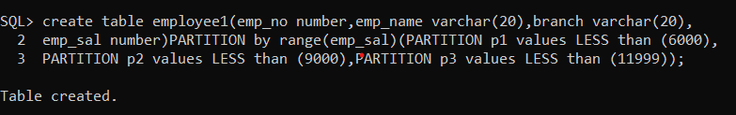

insert into employee1 values(1,'Shivam','Pune',8000);

insert into employee1 values(2,'Mangesh','Washim',5000);

insert into employee1 values(3,'Yogesh','Thane',10000);

insert into employee1 values(4,'Shubham','Nagar',4500);

insert into employee1 values(4,'Shubham','Nagar',4500);

select *from employee1;

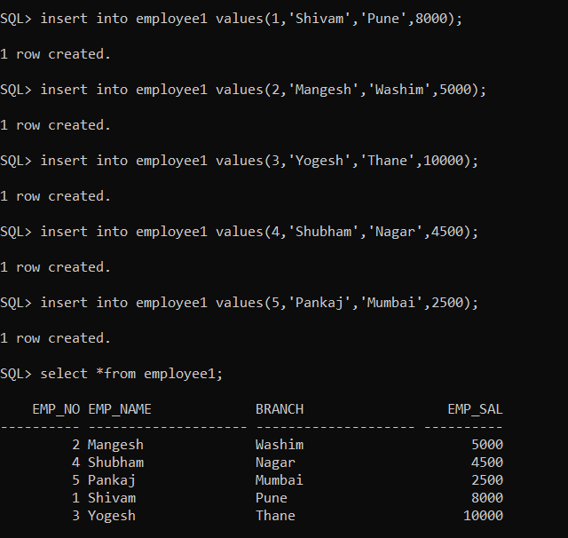

select * from employee1 PARTITION(p1);

select * from employee1 PARTITION(p2);

select * from employee1 PARTITION(p3);

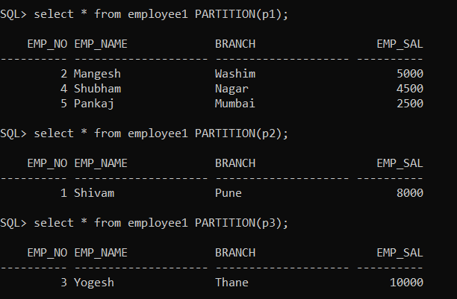

select sum(emp_sal),emp_no from employee1 group by emp_no;

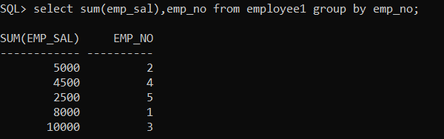

select * from employee1 order by emp_sal;

select * from employee1 order by emp_sal desc;

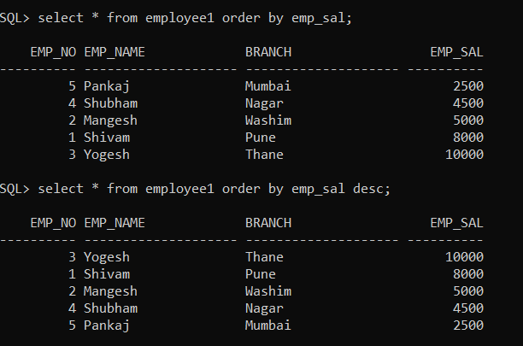

create table student1(name varchar(20),age number)PARTITION by range(age)(PARTITION a1 values LESS than (20),PARTITION a2 values LESS than (30));

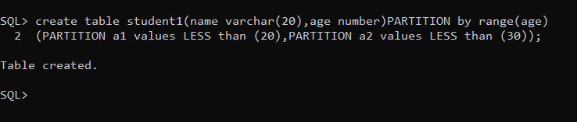

insert into student1 values('Mahesh',20);

insert into student1 values('Tushar',15);

insert into student1 values('Vaibhav',25);

insert into student1 values('Aniket',18);

insert into student1 values('Abhi',29);

insert into student1 values('Chetan',12);

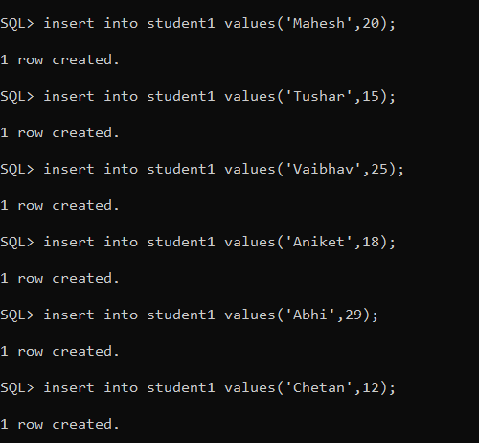

select *from student1;

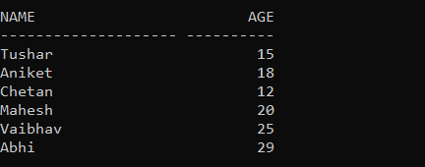

select * from student1 PARTITION(a1);

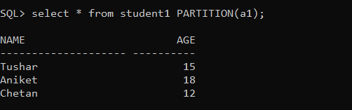

select * from student1 PARTITION(a2);

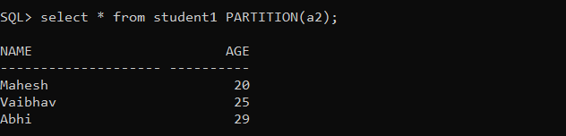

**Practical No 2**

**Aim: Implementation of Analytical Queries like RollUp,CUBE,First ,Last, Lead, Lag, Rank & Dense Rank.**

**\*\*\*\*\*\*\*\*\*\*\*\*\*\*\*\*\*\*\*\*\*\*\*\*\*\*\*\*\*\*\*\*\*\*\*\*\*\*\*\*\*\*\*\*\*\*\*\*\*\*\*\*\*\*\*\*\*\*\*\*\*\*\*\*\*\*\*\*\*\*\***

select emp_name,branch,emp_sal,rank() over (order by emp_sal)"Rank" from employee1;

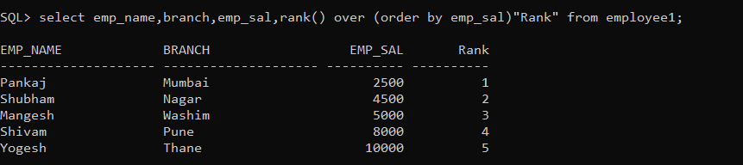

select emp_name,branch,emp_sal,dense_rank() over (order by emp_sal)"Rank" from employee1;

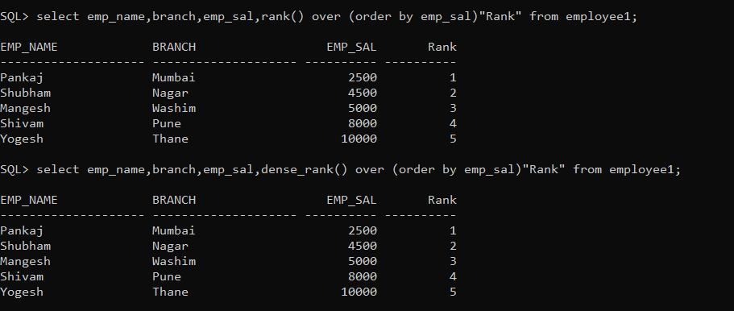

Select emp_name,emp_no,emp_sal,branch,min(emp_sal)keep(dense_rank first order by emp_sal )over (partition by branch)"lowest",max(emp_sal)keep(dense_rank last order by emp_sal )over(partition by emp_no)"highest"

from employee1 order by emp_no,emp_sal;

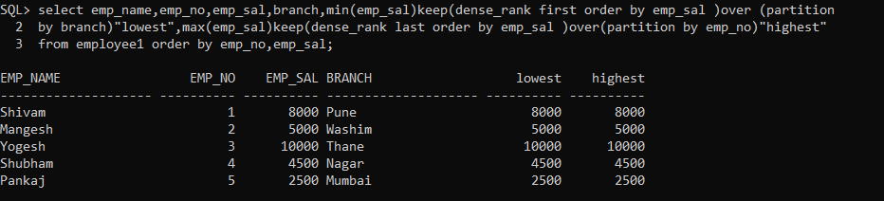

select emp_name,branch,sum(emp_sal) from employee1

GROUP BY cube(emp_name,branch) ORDER BY emp_name,branch;

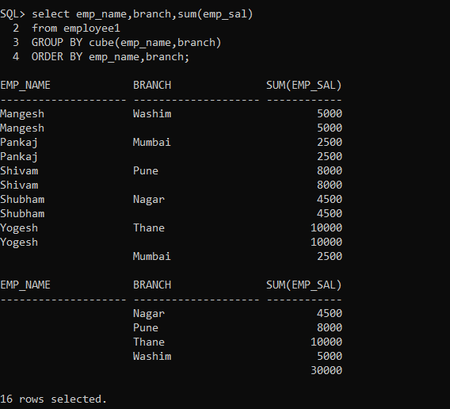

select emp_name,branch,sum(emp_sal) from employee1

GROUP BY rollup(emp_name,branch) ORDER BY emp_name,branch;

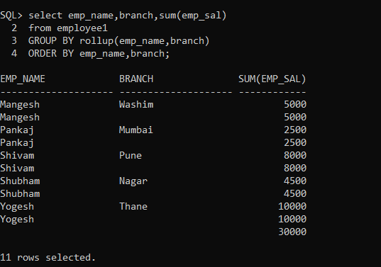

create table product (

prdno varchar(20), prodname varchar(25), rate number, qty_avilable number)

partition by list(prdno) (

partition pd1 values('p01','p02','p03','p04'),

partition pd2 values('a01','a02','a03','a04'),

partition pd3 values('b01','b02','b03','b04'),

partition pd4 values('c01','c02','c03','c04')

);

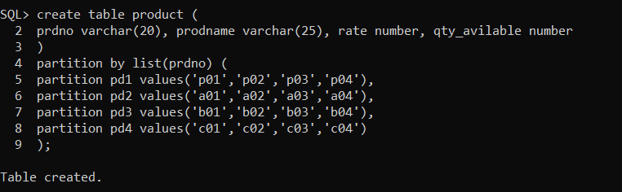

insert into product values('b01','books',30,40);

insert into product values('a01','pen',45,50);

insert into product values('p01','Rubber',60,65);

insert into product values('c01','Chocolate',10,15);

insert into product values('a02','colour_pen',70,50);

select *from product;

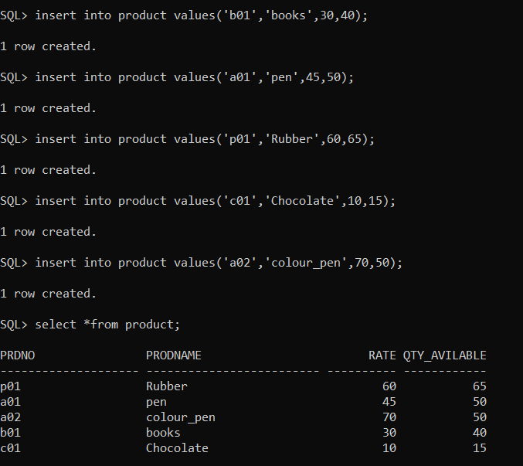

select * from product partition(pd1);

select * from product partition(pd2);

select * from product partition(pd3);

select * from product partition(pd4);

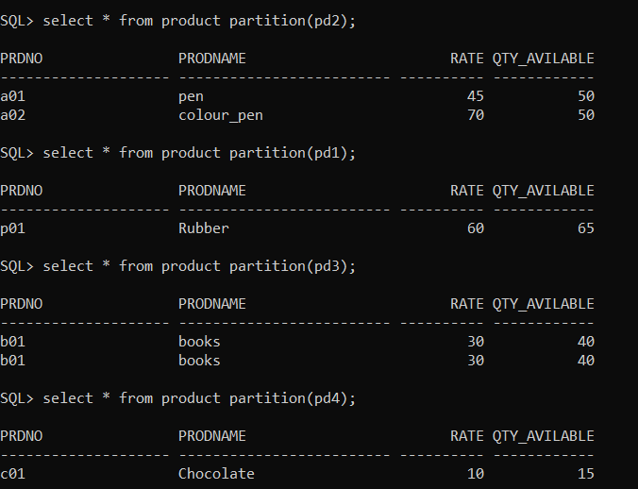

Cricket:

create table cricket1(name varchar(20),team varchar(20),run number);

insert into cricket1 values('Virat','IND',120);

insert into cricket1 values('Sachin','IND',150);

insert into cricket1 values('DJ bravo','west indies',200);

insert into cricket1 values('Watson','australian',190);

insert into cricket1 values('Stokes','london',100);

insert into cricket1 values('Maxwell','australian',250);

insert into cricket1 values('MS Dhoni','IND',250);

insert into cricket1 values('madhura','west indies',300);

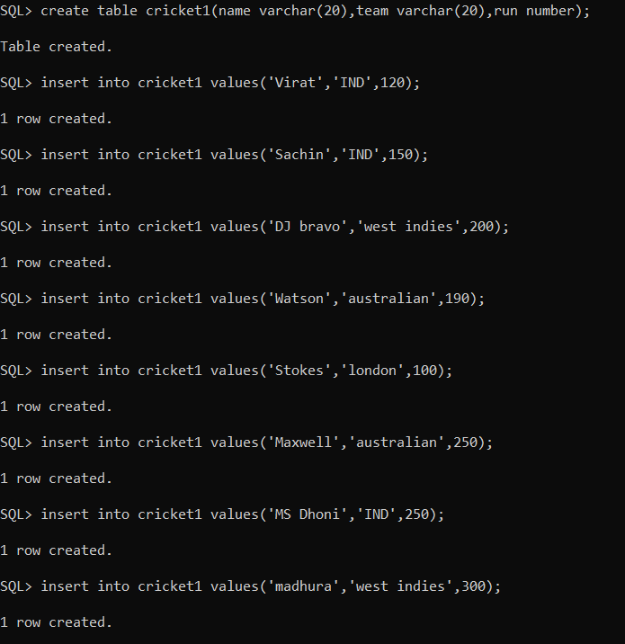

select *from cricket1;

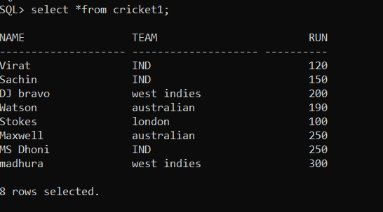

select name,team,run,rank() over (order by run)"Rank" from cricket1;

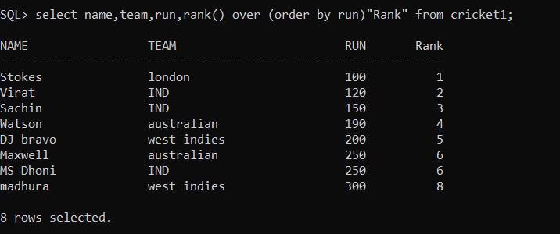

select name,team,run,dense_rank() over (order by run)"DenseRank" from cricket1;

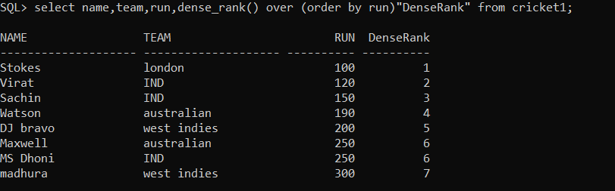

select name,team,run,min(run)keep(dense_rank first order by run)over(partition by team)"Lowest"

,max(run)keep(dense_rank last order by run)over(partition by team)"highest" from cricket1 order by run,team;

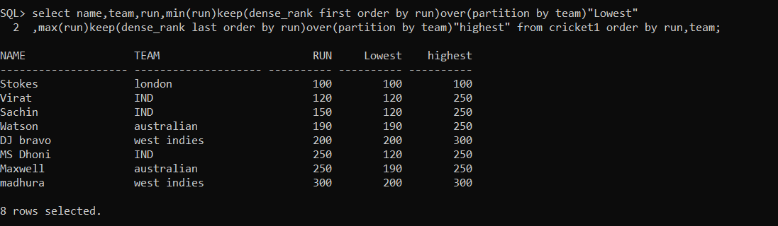

create or replace type ptype as object(sizes number,color varchar(20),

article varchar(20));

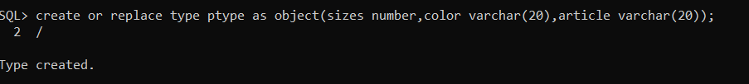

create table product1(prod_id number,prod_name ptype);

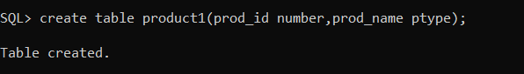

insert into product1 values(1,ptype(10,'red','adx123'));

insert into product1 values(2,ptype(30,'orange','rdg456'));

insert into product1 values(3,ptype(25,'blue','jhg576'));

insert into product1 values(4,ptype(40,'pink','ewd481'));

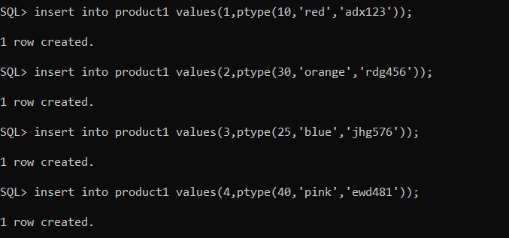

select p.prod_id,p.prod_name.sizes,p.prod_name.color,p.prod_name.article from product1 p;

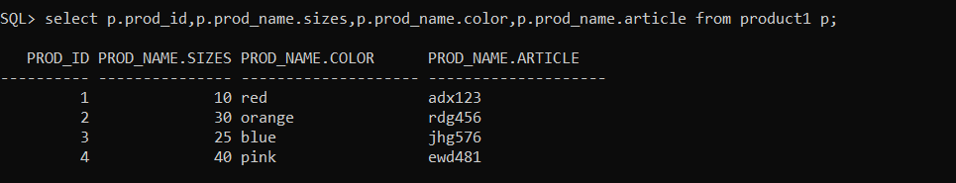

select p.prod_id,p.prod_name.sizes from product1 p;



select p.prod_id,p.prod_name.color from product1 p;

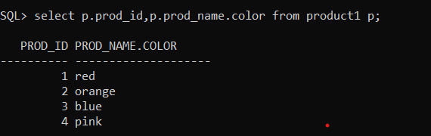

select p.prod_id,p.prod_name.article from product1 p;



create table student(name varchar(20),age number,year varchar(20),marks number);

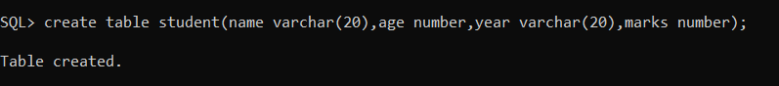

insert into student values('mayuri',21,'fymca',80);

insert into student values('manasi',25,'symca',85);

insert into student values(‘Vaibhav’,19,'fymca',75);

insert into student values('aniket',22,'tymca',90);

insert into student values('yash',24,'tymca',55);

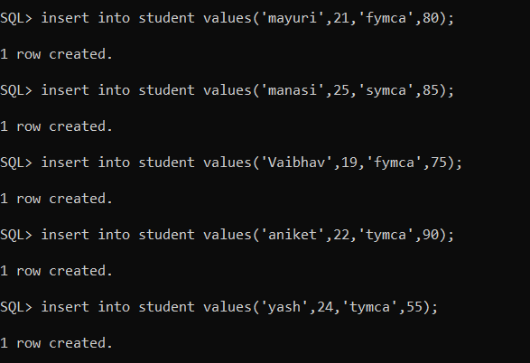

select name,age,year,marks,min(marks)keep(dense_rank first order by marks)over(partition by year)"first",max(marks)keep(dense_rank last order by marks)over(partition by year)"last" from student order by marks,year;

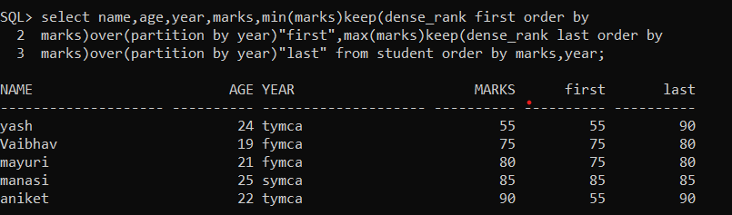

**Practical No – 3**

**Aim: Implementation of Abstract Datatype.**

**\*\*\*\*\*\*\*\*\*\*\*\*\*\*\*\*\*\*\*\*\*\*\*\*\*\*\*\*\*\*\*\*\*\*\*\*\*\*\*\*\*\*\*\*\*\*\*\*\*\*\*\*\*\*\*\*\*\*\*\*\*\*\*\*\*\*\*\*\*\*\*\*\*\*\*\***

**Q1) Create an ADT name_type with the attribute fname, mname and lname to store the name details**

CREATE TYPE name_type as object ( fname varchar(20),mname varchar(20),lname varchar(20));

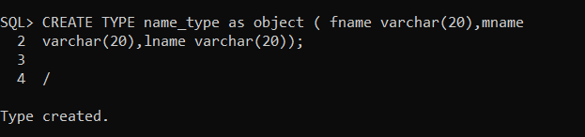

**Create a table customer with the attributes cust_no, cust_name of name_type, product and price.**

CREATE TABLE customer (id number,name name_type,product varchar(25),price int);

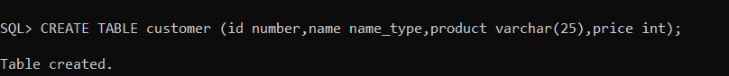

insert into customer values(1,name_type('sam','john','andrew'),'PC',65000);

insert into customer values(2,name_type('shubs','sham’,’salunke’),'camera',55000);

insert into customer values(3,name_type('a','b','c'),'laptop',45000);

insert into customer values(4,name_type('x','y','z'),'tablet',25000);

insert into customer values(5,name_type('p','q','r'),'mobile',15000);

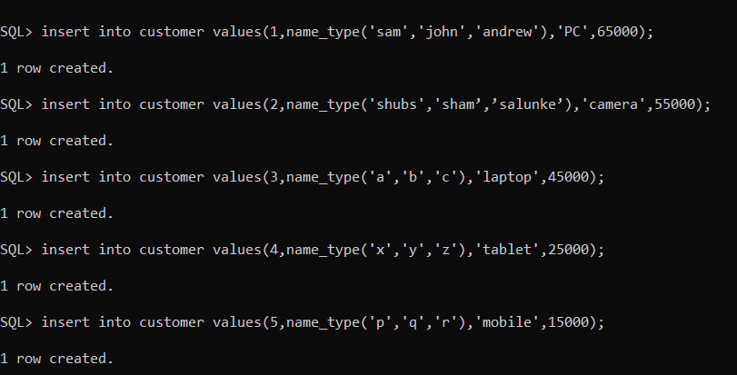

**Display the first name of all the customers.**

select c.name.fname from customer c;

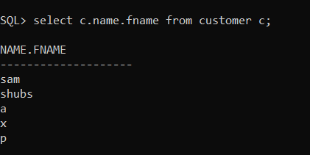

**Display the details of customer who purchase the ‘Laptop’.**

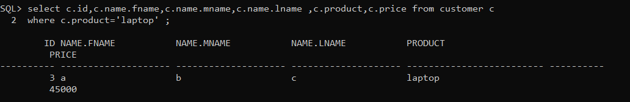

**Q2) Create an date_type with the attribute day, month and year to store the date details**

Create or replace type date_type as object ( day number(2), month number(2),year number(4));/

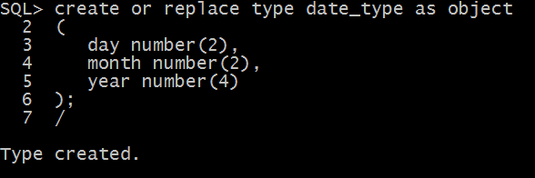

**Create a table ordertest with the attributes ord_no, item,cust_name,order_date of date_type**

Create table ordertest(ordno number(5),item varchar (10),custname varchar(10),ord_date date_type);

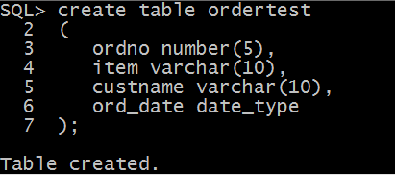

insert into ordertest values(1001,’Shirts’,’Max’,’date_type(2,5,2018));

insert into ordertest values(1002,’Trousers’,’Jack’,’date_type(3,2,2018));

insert into ordertest values(1003,’T-Shirts’,’Blake’,date_type(10,12,2019));

insert into ordertest values(1004,’Shoes’,’Billy’,’date_type(20,8,2020));

insert into ordertest values(1005,’Jeans’,’Clark’,’date_type(25,10,2018));

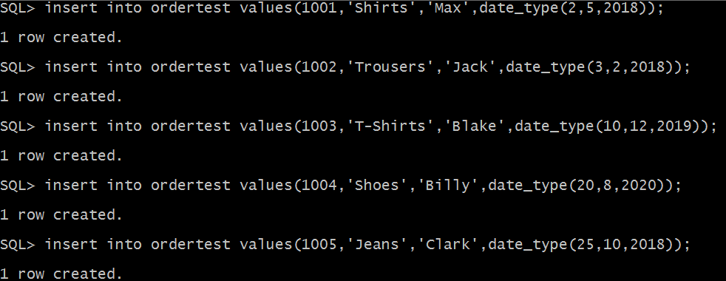

**Display the total number of orders dispatched in the year 2018.**

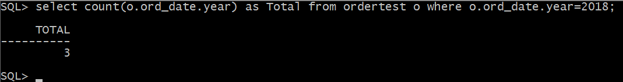Select count(o.ord_  
date.year)as Total from orertest o where o.ord_date.year=2018;

**Display the orders in the descending order of month and year.**

Select *from ordertest o ORDER BY o.ord_date.month DESC,o.ord_date.year DESC;

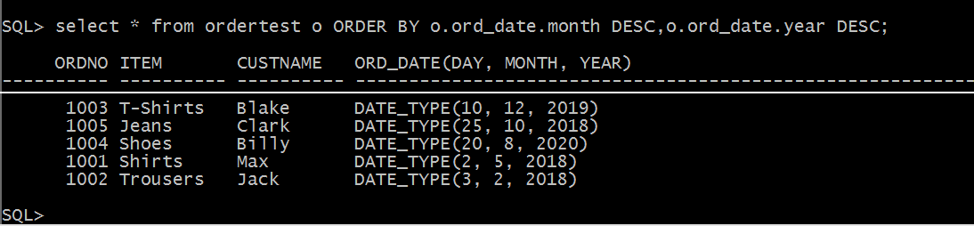

**Q3) Create abstract datatype of Book_type containing Bookno, Title, Author, pub_date, price.**

**Create a table Books of Book_type.**

CREATE TYPE book_type as object (book number(5), title varchar(10), author varchar(10), pub_date date, price number(5));/

CREATE TABLE Book of book_type /

insert into Books values(book_type(101,'JAVA','Cornell','2-February-2018',1200));

insert into Books values(book_type(102,'CN','Tanenbaum','3-March-2018',1300));

insert into Books values(book_type(103,'C++','Rossum','20-December-2017',800));

**Display the book details written by the author “Tanenbaum‟.Display the**

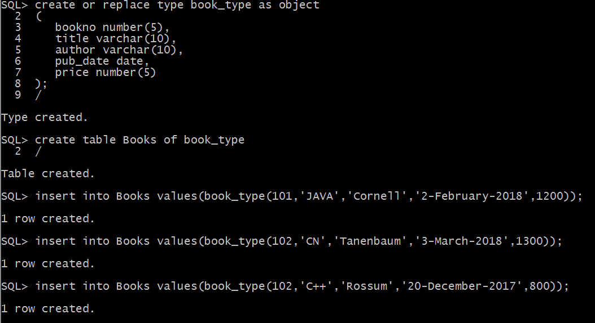

**Display the book details written by the author “Tanenbaum”.**

Select *from Books b where b.author=’Tanenbaum’;

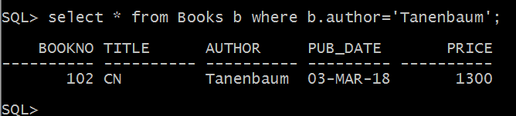

**Display Books having a prices in the range of 1000 to 2500 and published after January 2018**

Select *from Books b where b.price>1000 and b.price<2500 and b,pub_date>’31-January-2018’;

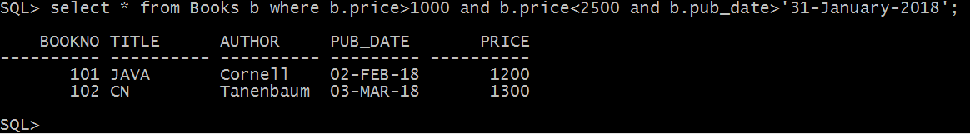

**Q4) Create object table hostel of hostel_type(with attributeshost_no, host_name and type(boys/girls))**

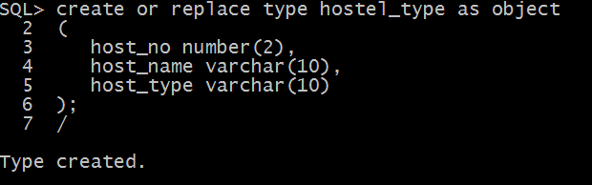Create or replace type hostel_type as object (host_no number(2),host_name varchar(10),host_type varchar(10));/

**Create a table Student with attributes sid, sname, gender, year, hostel_info referencing object table.**

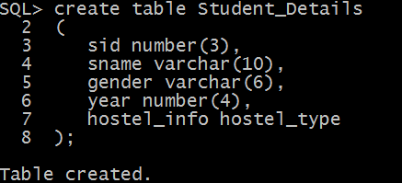Create table Student_Details( sid number (3), sname varchar(10),gender varchar1(6),year number (4),hostel_info hostel_type);

insert into Srudent_Details values(101,’Jack’,’Male’,2018,hostel_type(1,’ABC’,’Boys’));

insert into Srudent_Details values(102,’Arnalod’,’Male’,2019,hostel_type(1,’XYZ’,’Boys’));

insert into Srudent_Details values(103,’Blake’,’Male’,2018,hostel_type(1,’XYZ’,’Boys’));

insert into Srudent_Details values(104,’Ammy’,’Female’,2017,hostel_type(2,’XYZ’,’Boys’));

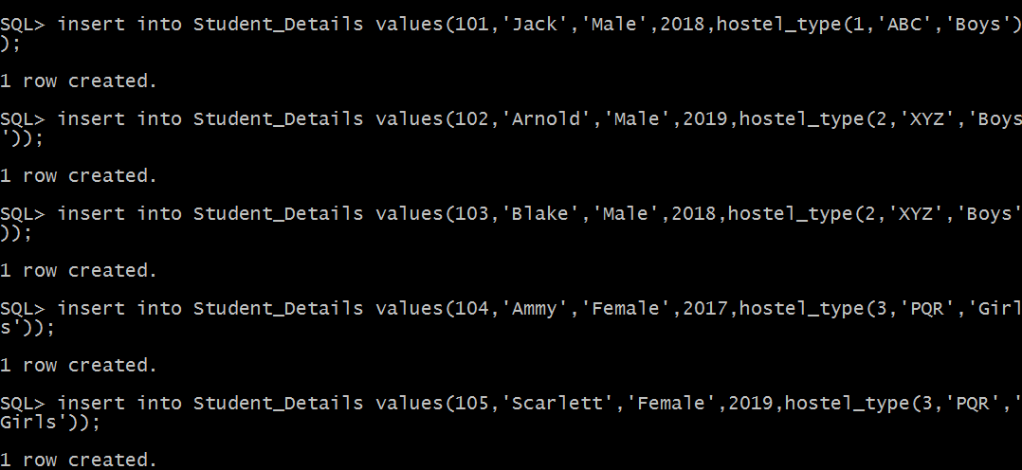insert into Srudent_Details values(105,’Scarlett’,’Female’,2018,hostel_type(1,’PQR’,’Boys’));

**Display the details of all girl students.**

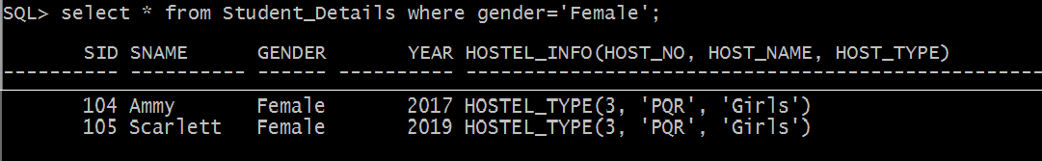select *from Student_Details where gender=’Female’;

**Display the students in hostel no 2.**

select *from Student_Details s where s.hostel_info.host_no=2;

### Practical No – 4

**Aim: Implementation of ETL transformation with pentaho like Copy data from source (table/excel/oracle) and store it to target (table/excel/oracle).** *************************************************************************

1. Open new transformation
2. Click on Input and drag and drop table input on the screen.

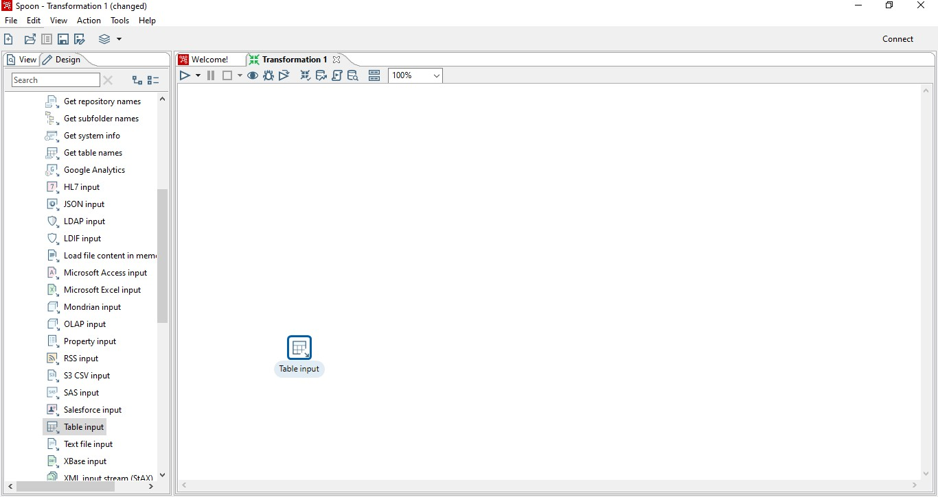

1.Double click on this table_input icon.

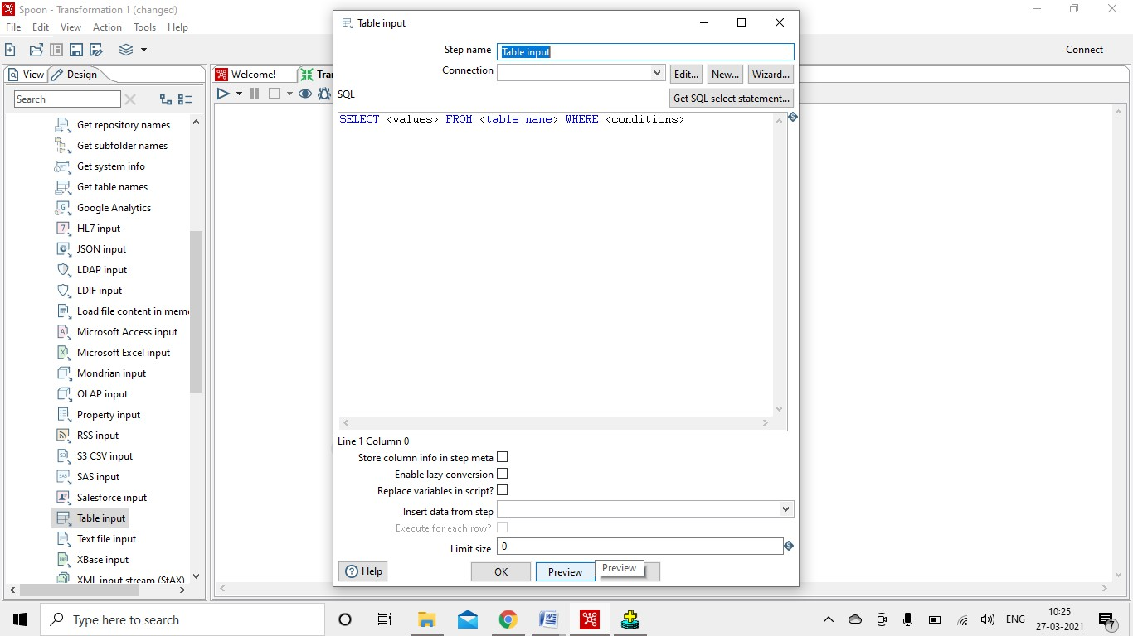

2.Click on new for creating a connection.

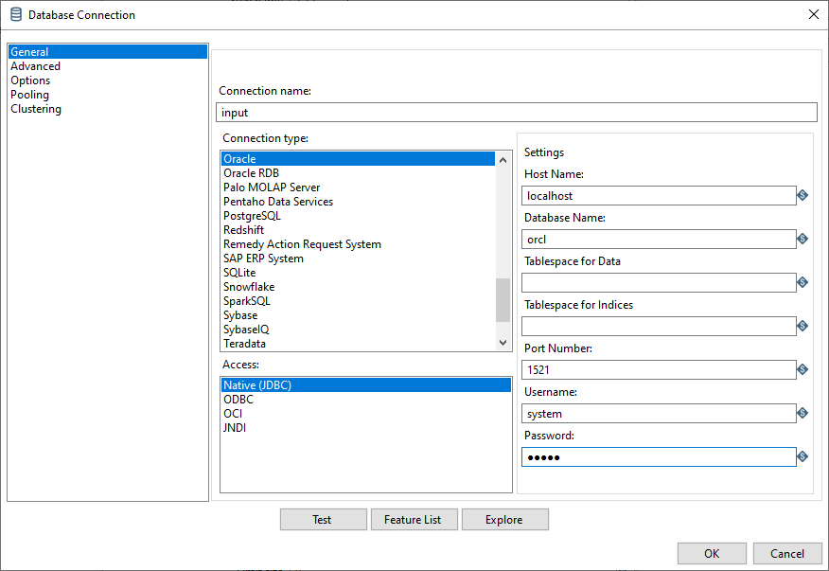

3.Click on test.

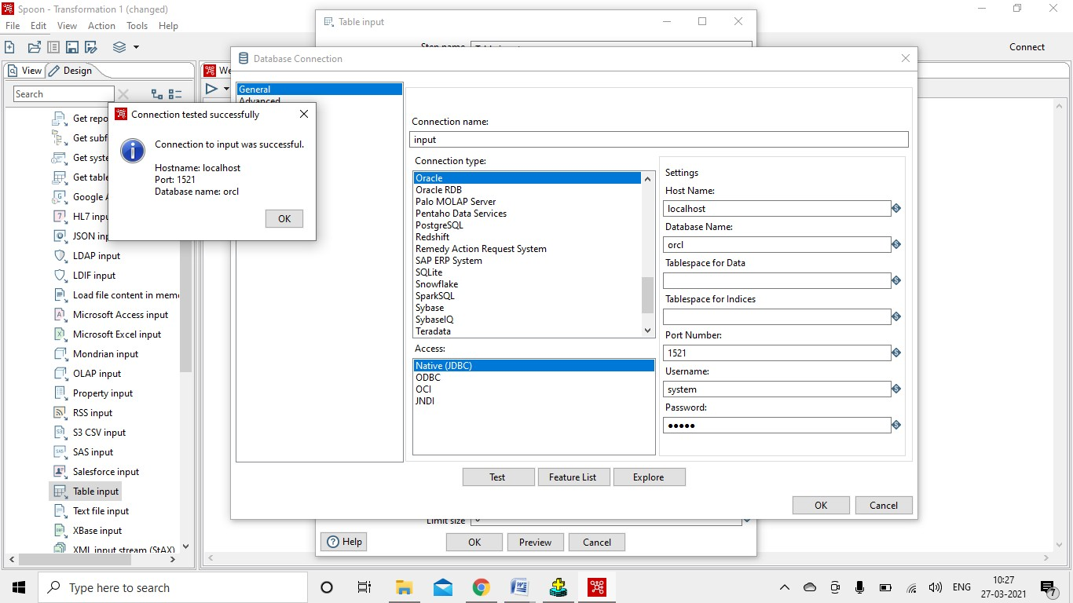

4.Click on OK. Then click on get SQL select statement.

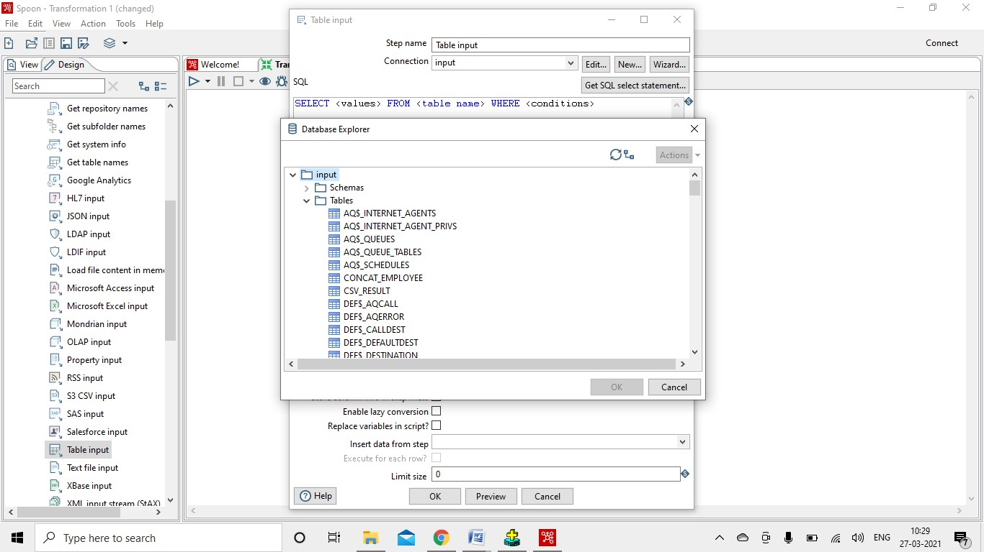

Select your table and click on OK. Then Click on Preview and then ok. Below given page will get open.

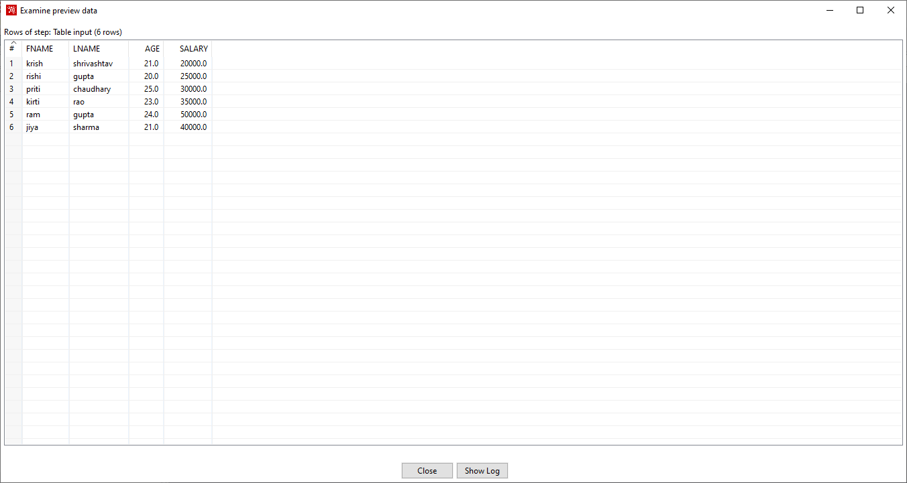

Click on close and then ok.

Data Input is Done Now we have to create a table for getting our output.

Go Output and Drag & Drop table output.

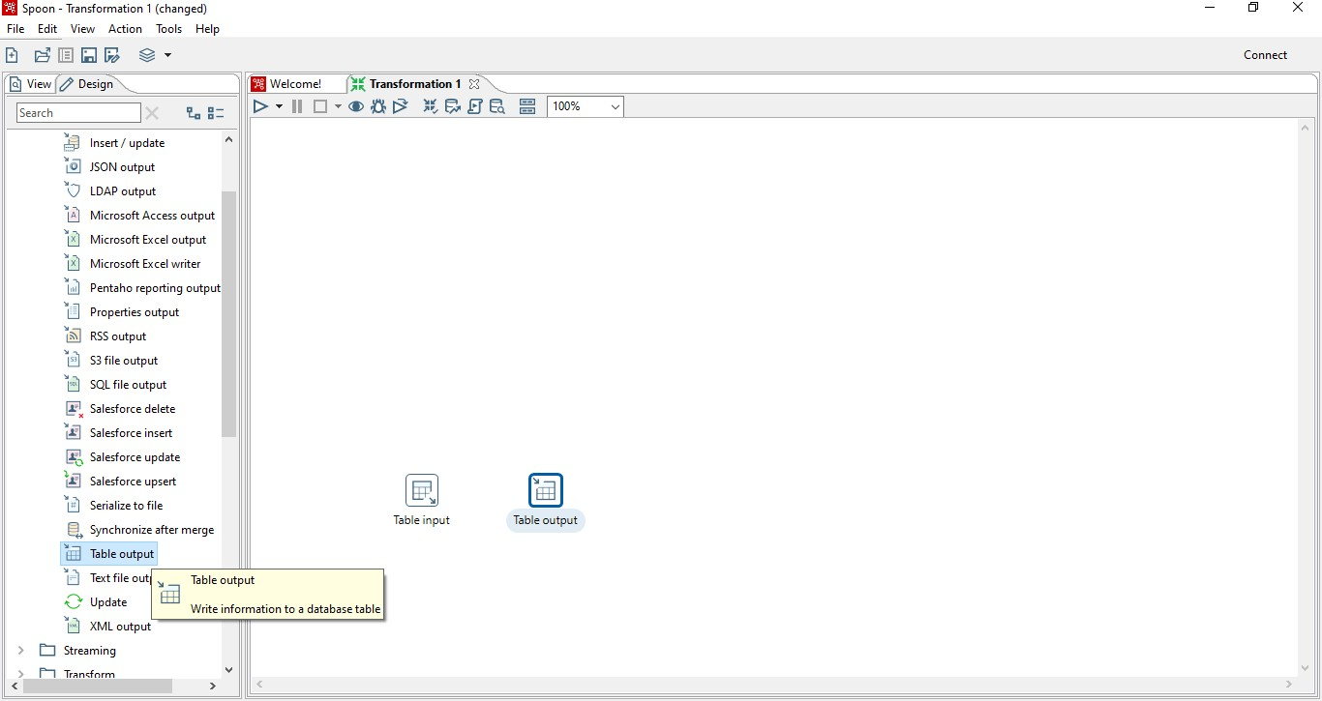

Make a Connection between them.

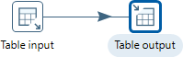

Double click on table output.

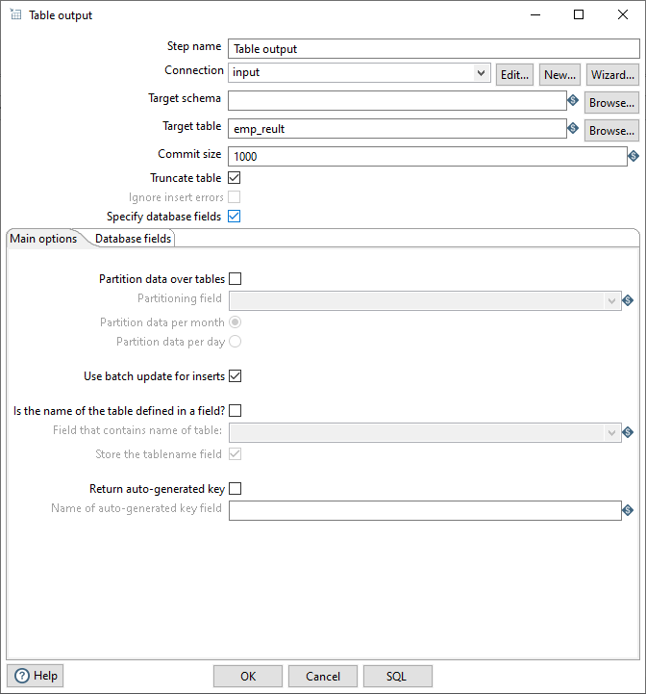

Give name to target table in which our input is going to get stored.

Select truncate table and specify database fields.

Click on SQL.

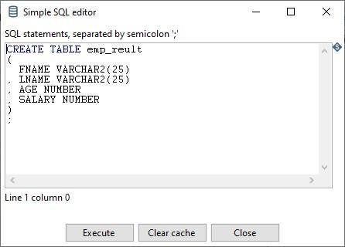

Click on execute then ok and close. Go in database fields and click on get fields

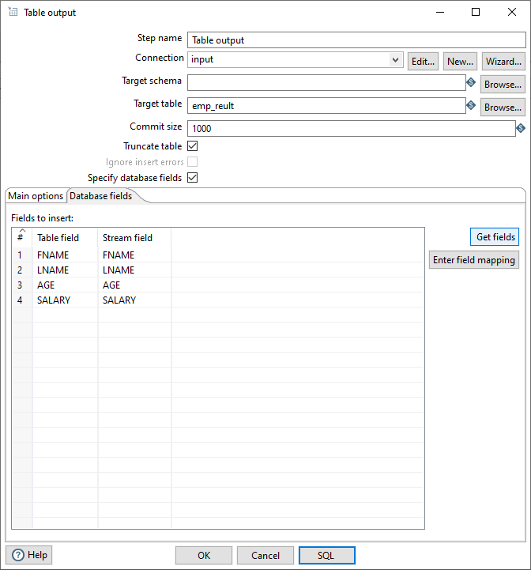

Click on OK.

And then Run.

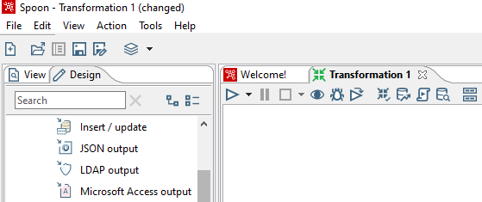

Run

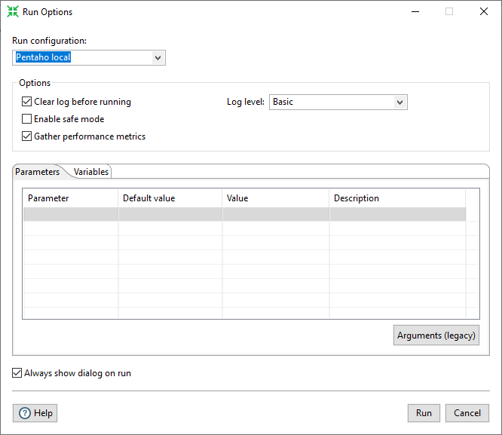

Click on Run.

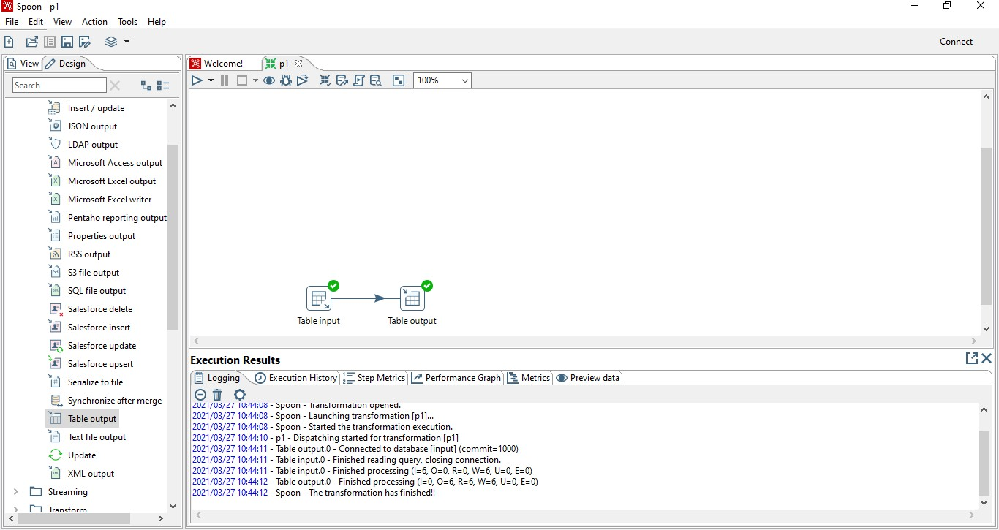

It is successfully done.

Now for checking our output go in SQL PLUS and type the table name which you have given in table_output.

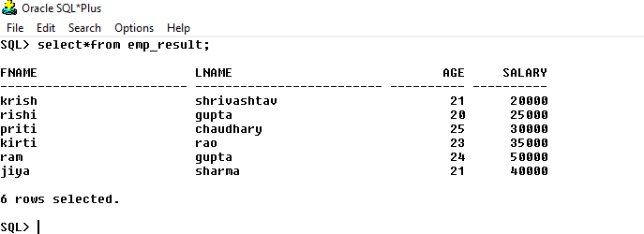

**Aim: Implementation of ETL transformation with Pentaho like Adding sequence. Number range**

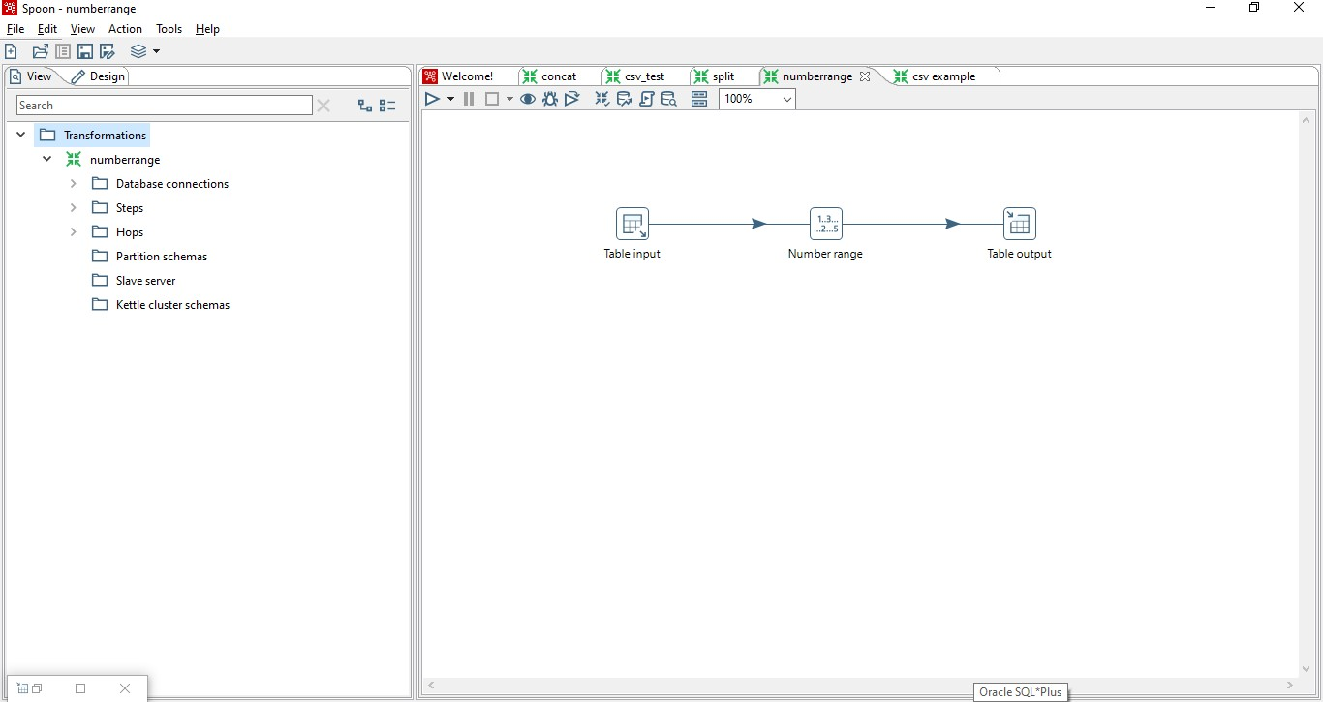

Input table

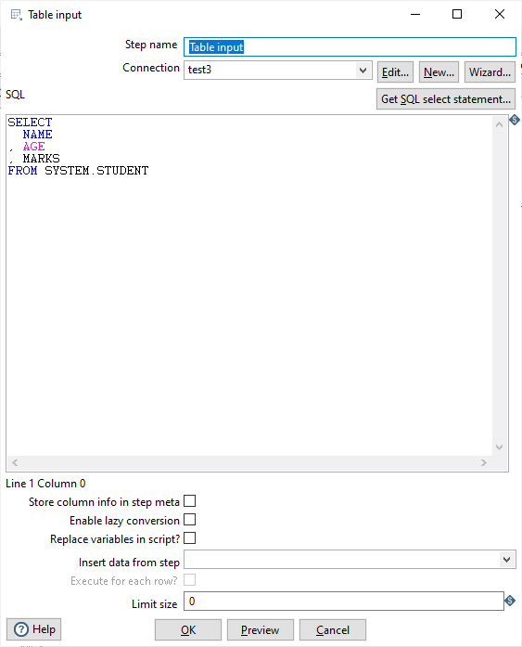

Preview data

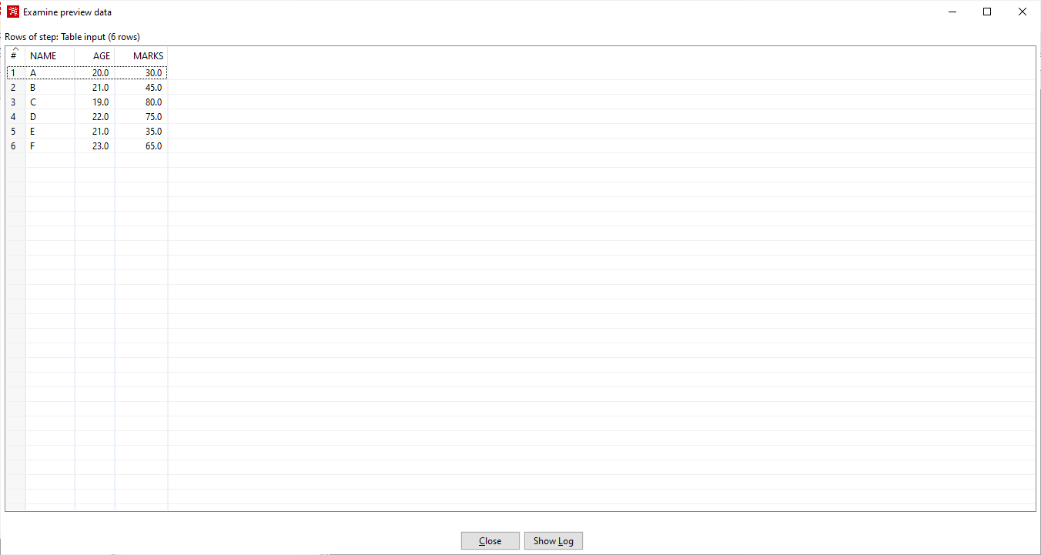

Number Range transformation as follows

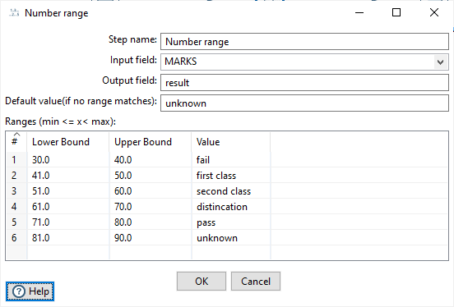

Run the transformation

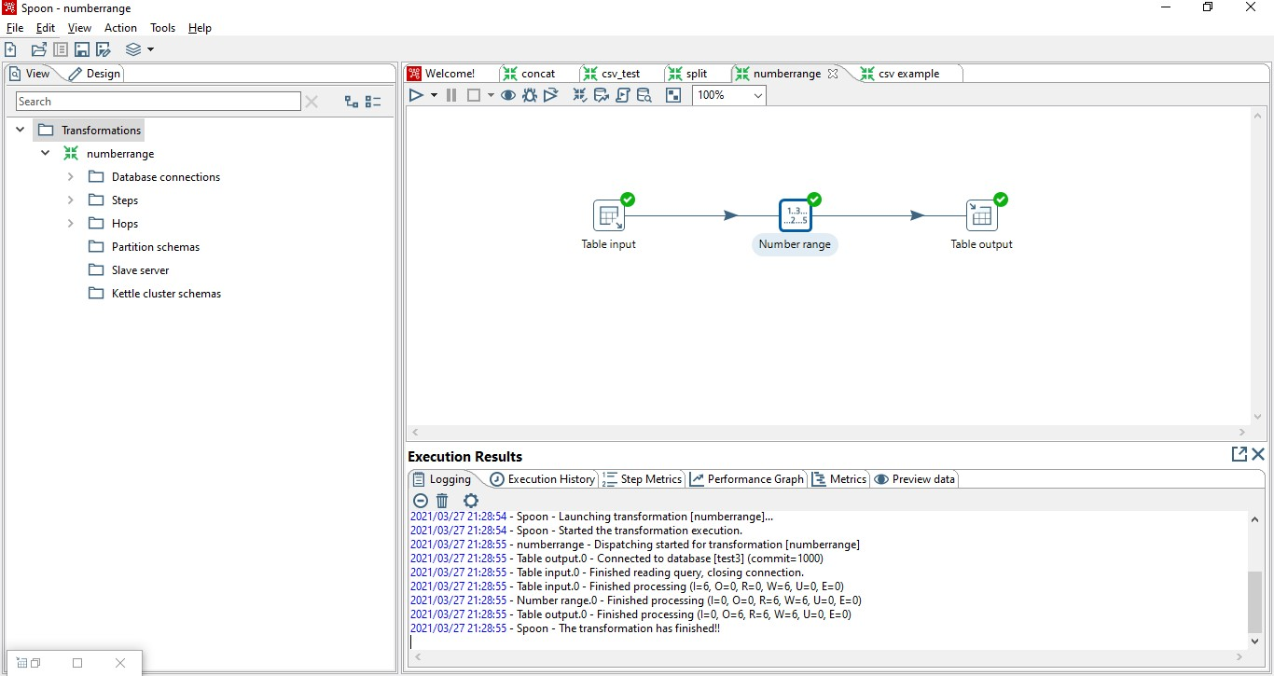

Output

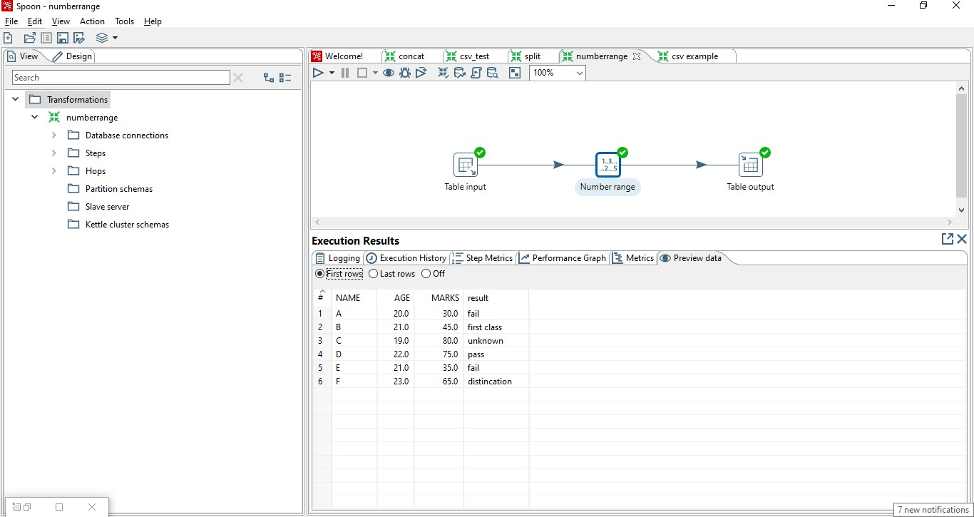

Sql Output

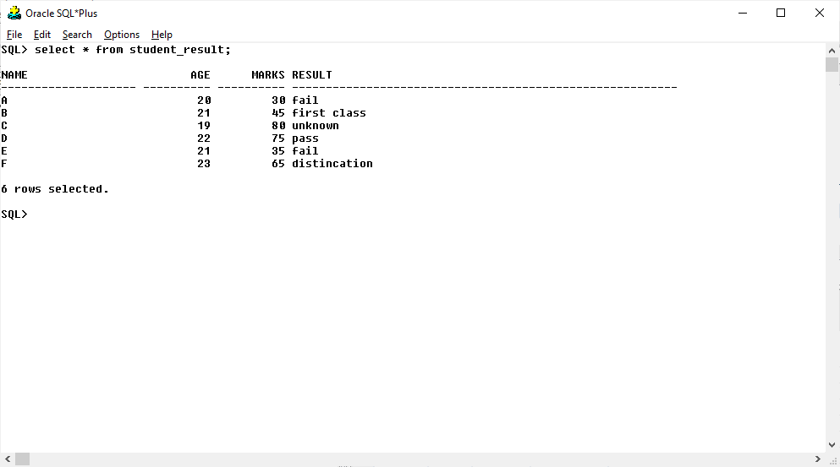

**Aim:** Implementation of ETL transformation with Pentaho like calculator.

### Calculator

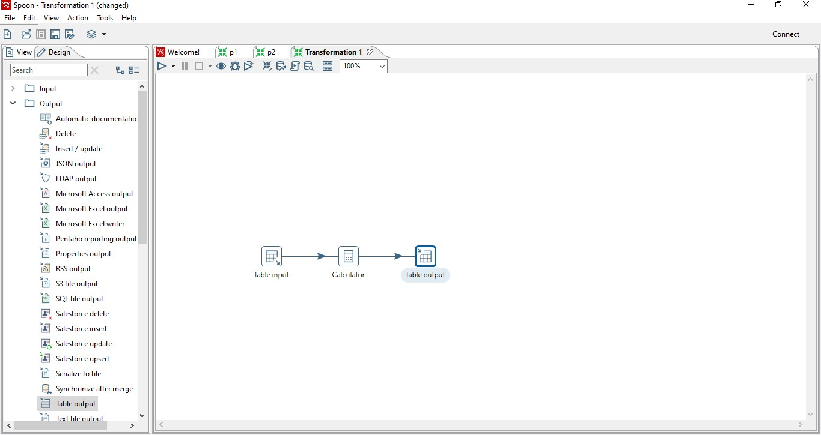

Double click on table input Get the Connection.

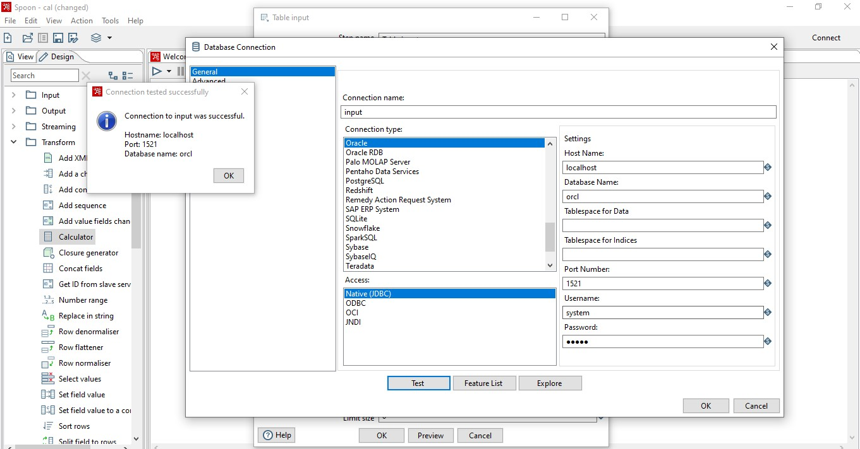

Click ok

Then go in SQL Select statement and select your table

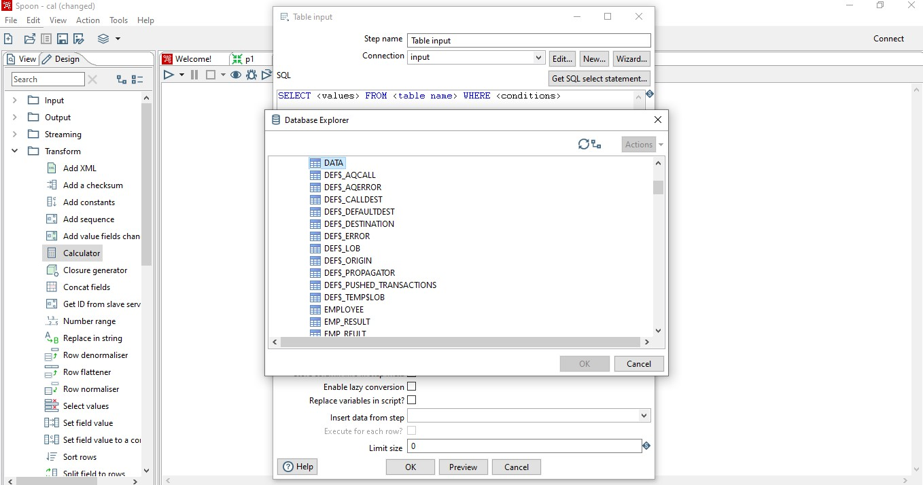

Click ok

Then Preview->close->OK Double Click on Calculator

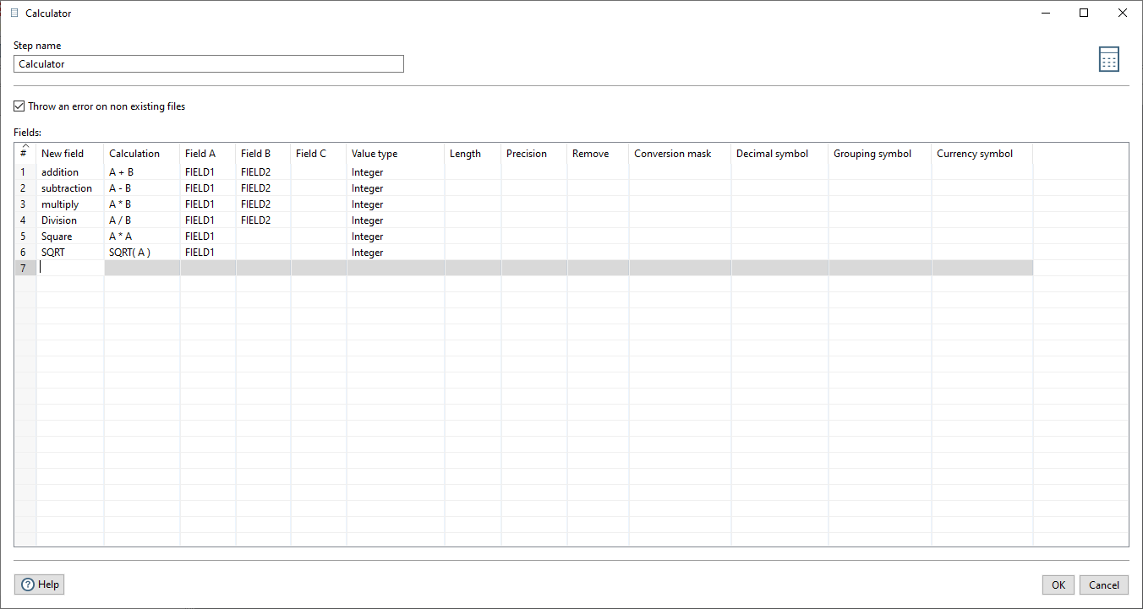

Click OK

Double click on table Output.

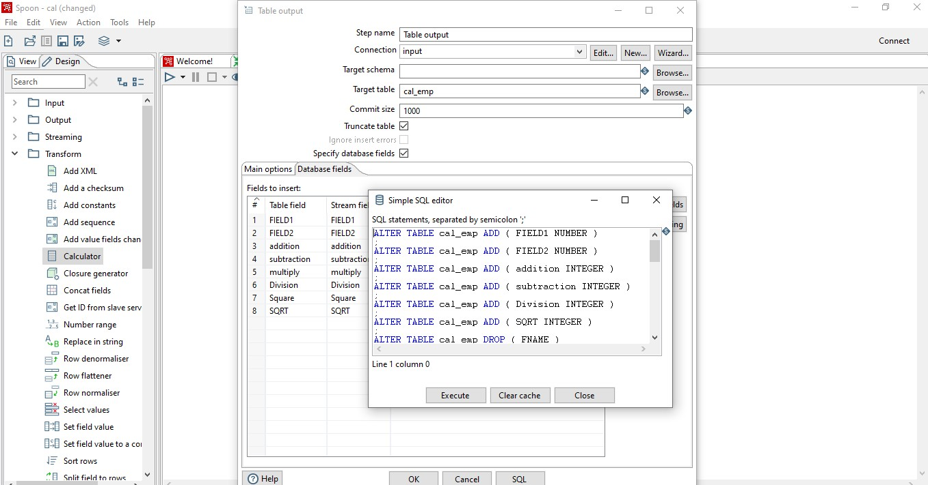

Get all the Fields. Execute-> OK Then Run

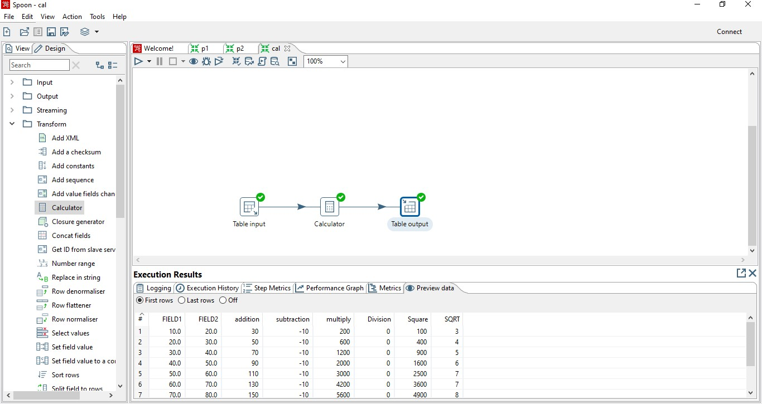

Now Let’s see the output in SQL PLUS

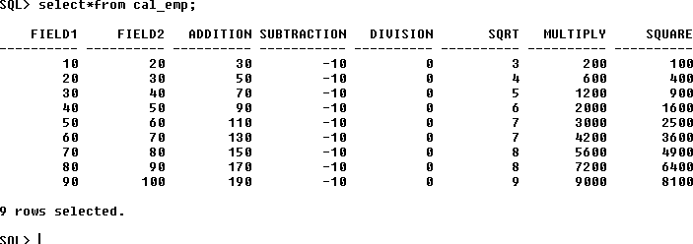

**Aim:** Implementation of ETL transformation with Pentaho like Splitting

of Two fields.

Split

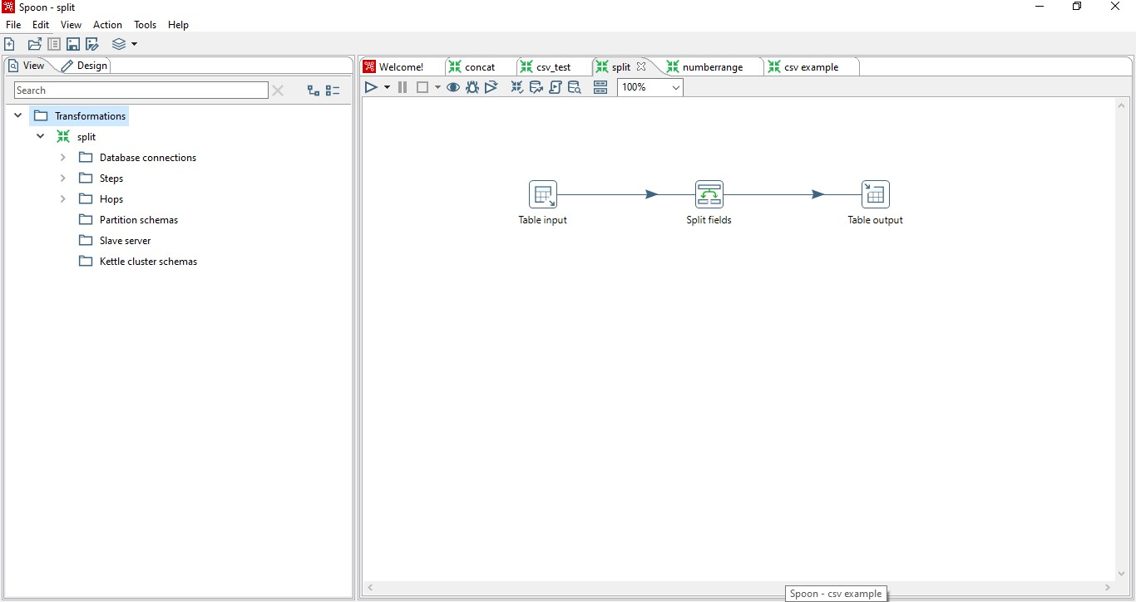

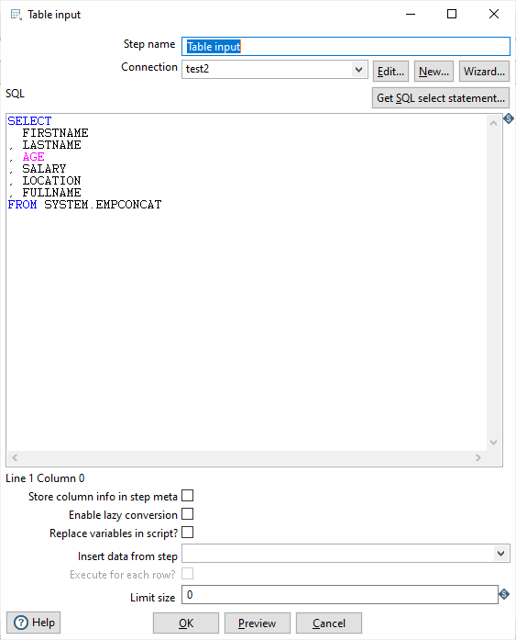

Click preview data

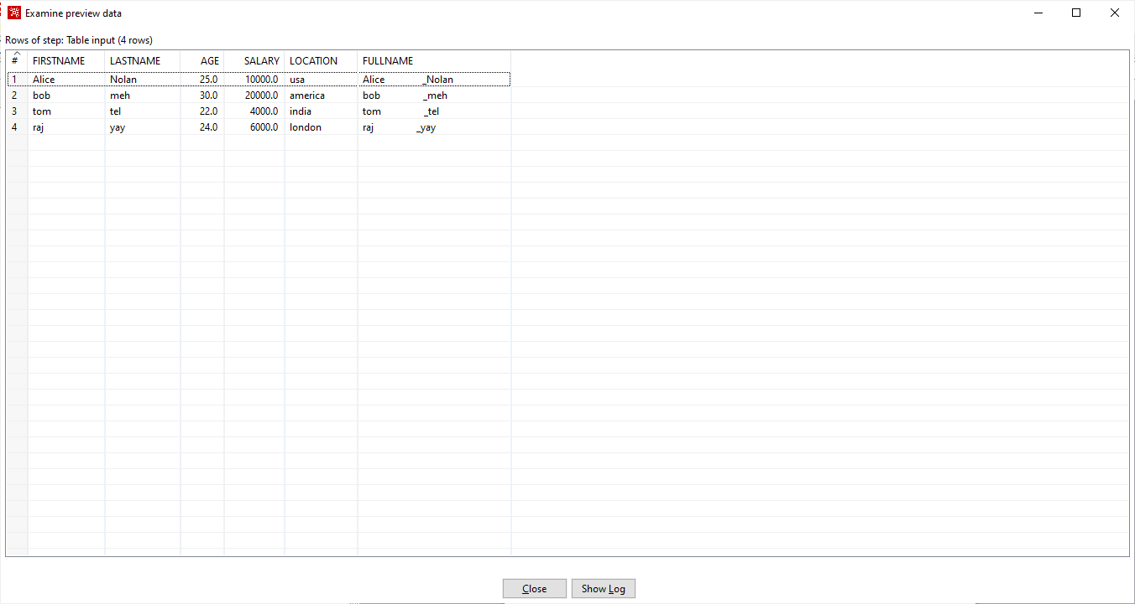

Click close

Select the transformation “SPLIT” Add the changes as follows

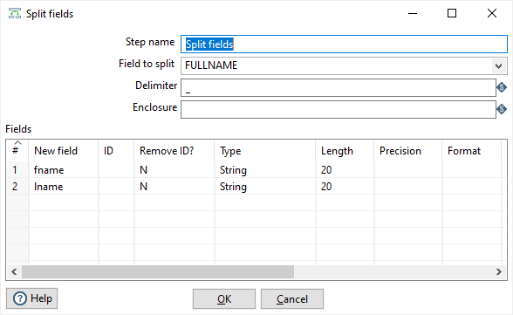

Click ok Output

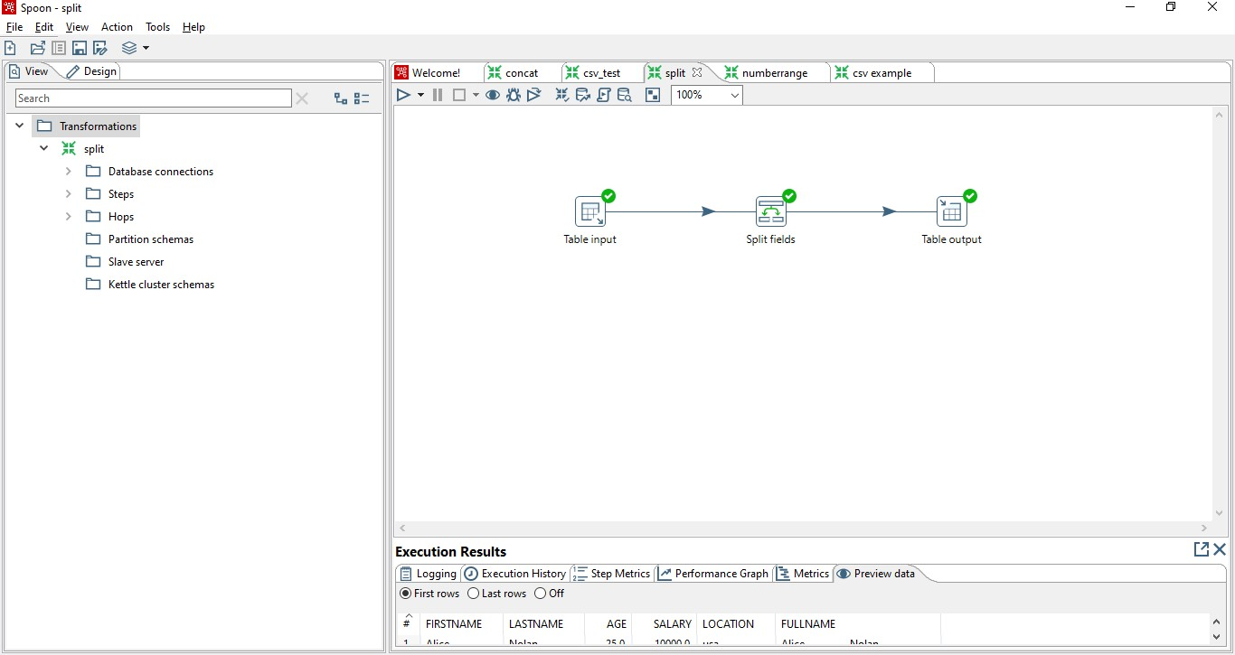

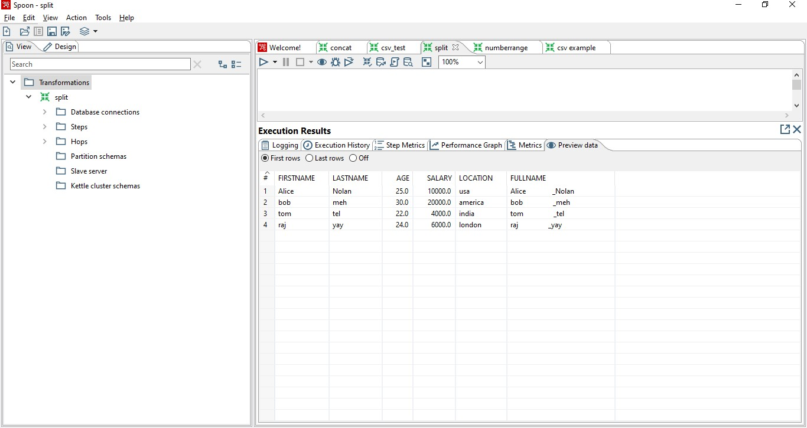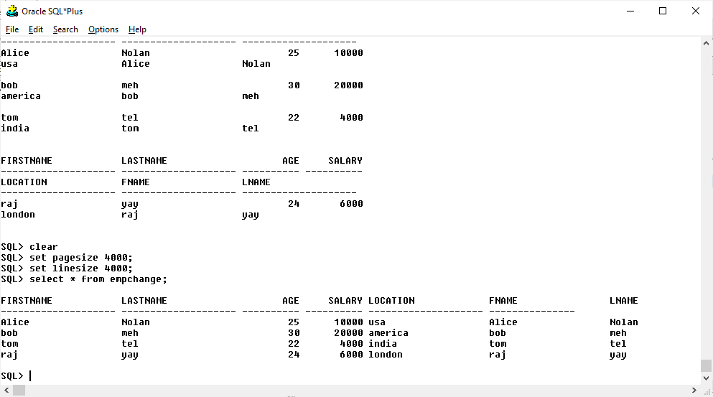

**Aim:** Implementation of ETL transformation with Pentaho like Number Range. Number range



Input table



Preview data



Number Range transformation as follows



Run the transformation



Output



Sql output



**Aim: Implementation of ETL transformation with Pentaho like Sorting Data.**

### Sorting

Drag & Drop Input & output table, sort rows and add sequence from transformation.

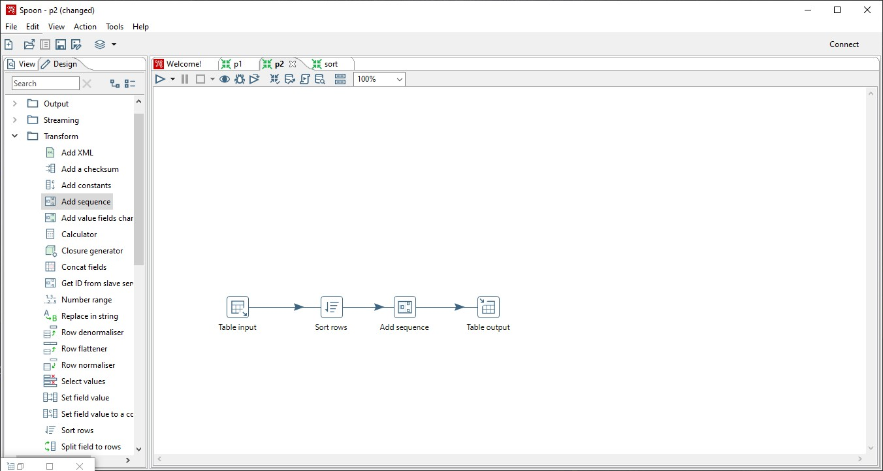

Double click on Input table. And create connection.

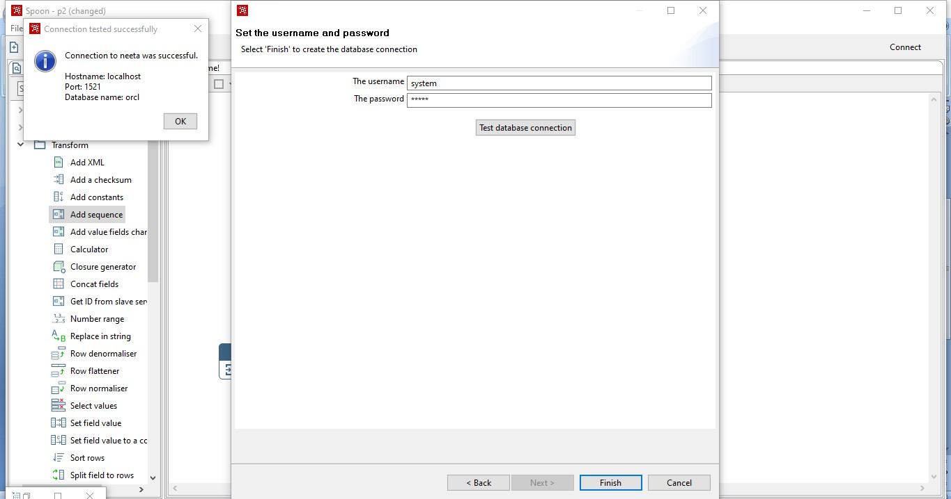

Select your table from Get SQL Select statement.

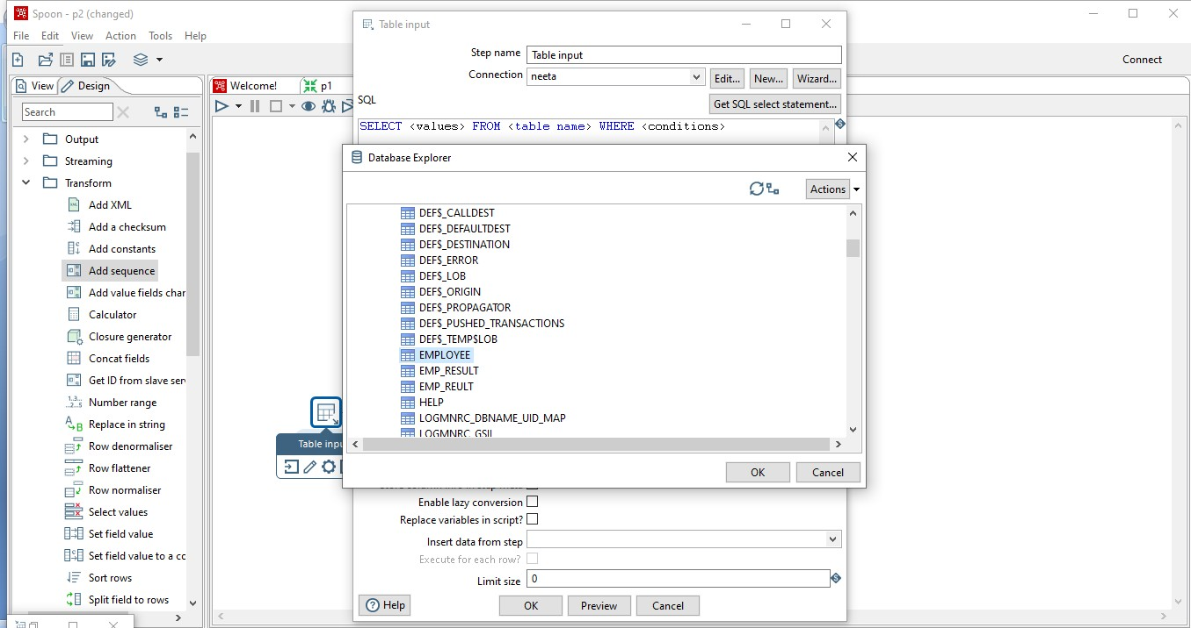

Click ok

Double click on sort rows. Click on get fields.

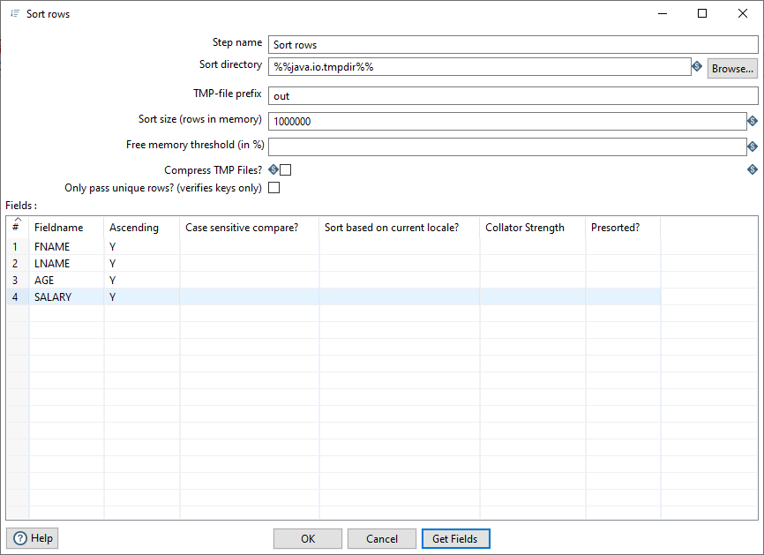

Click ok

Double click on Add Sequence.

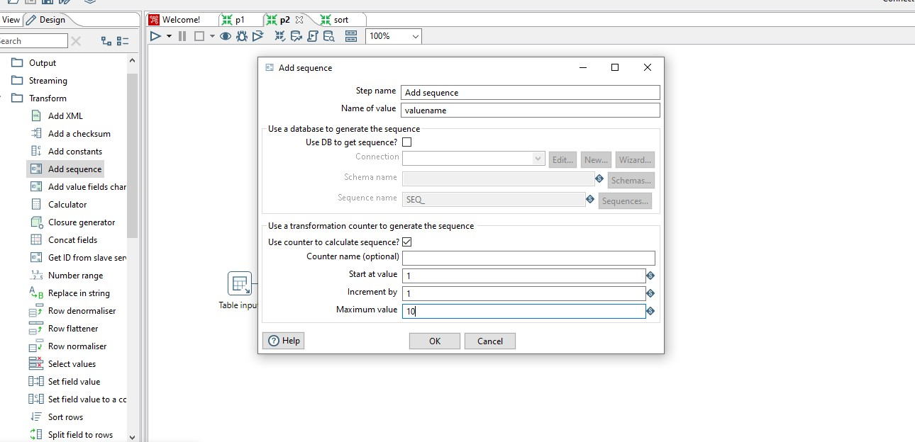

Click ok.

Double click on table output and give the name to your output table

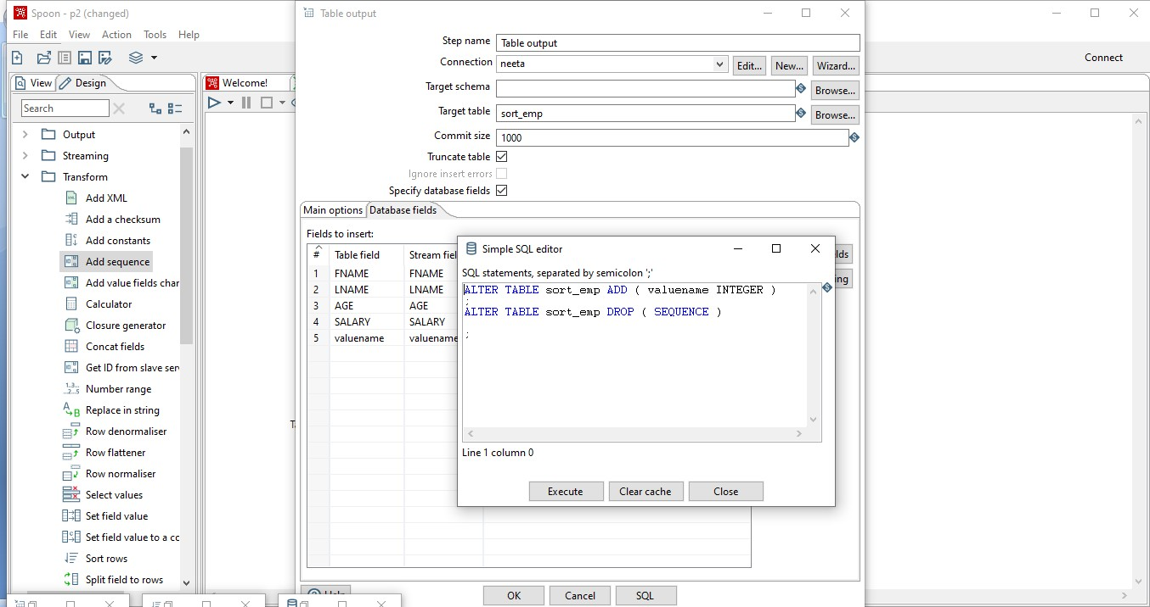

click on

execute and then ok And then Run.

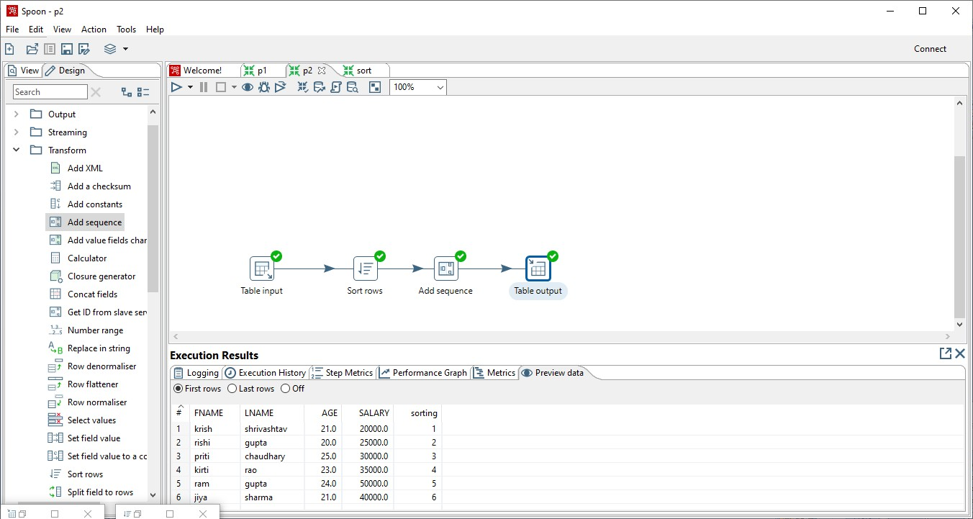

Let’s see our output in SQL PLUS.

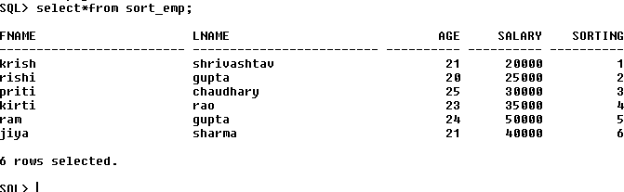

**Aim: Implementation of ETL transformation with Pentaho like CSV File.**

### CSV file

From the input table select “CSV INPUT TABLE”

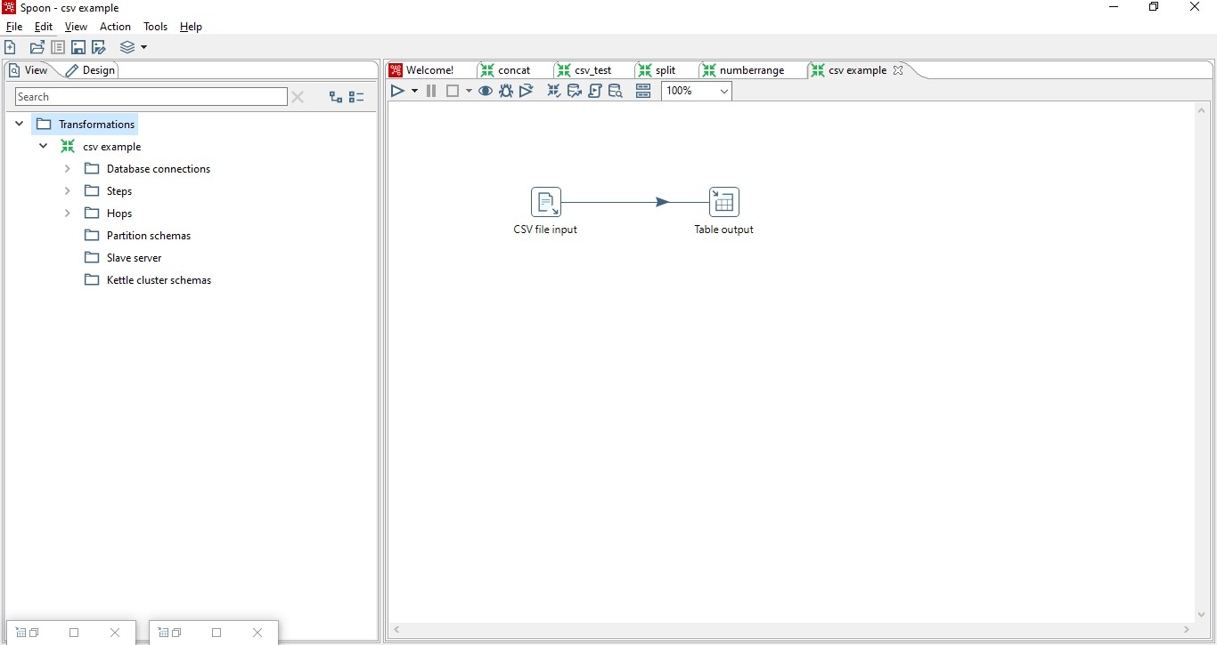

Make the following changes Browse for a csv file

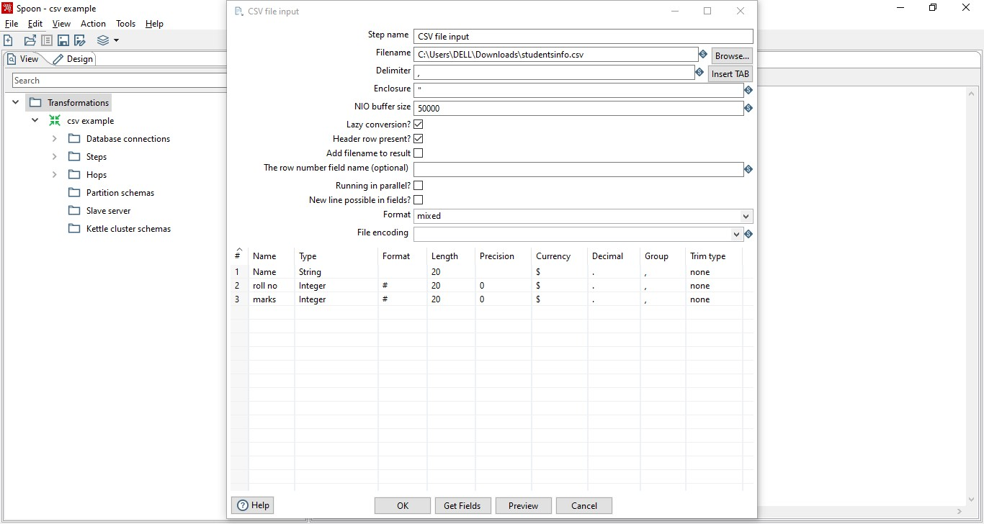

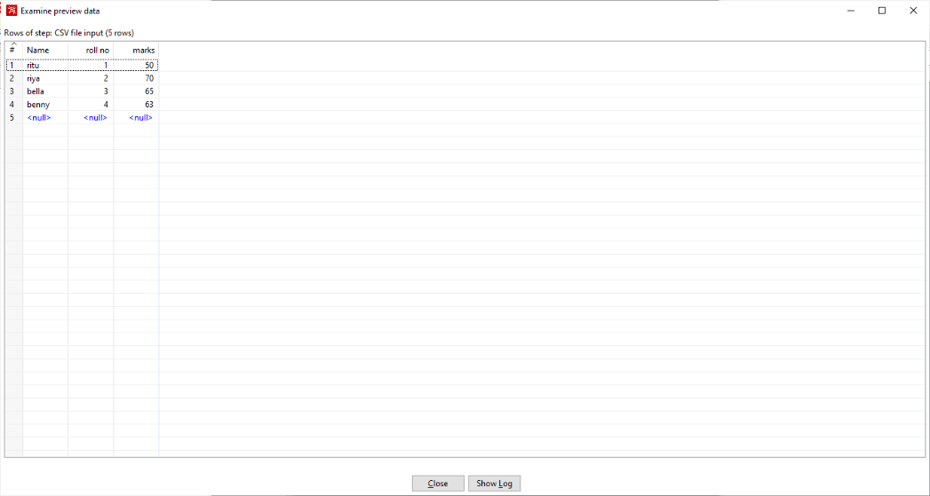

Output table

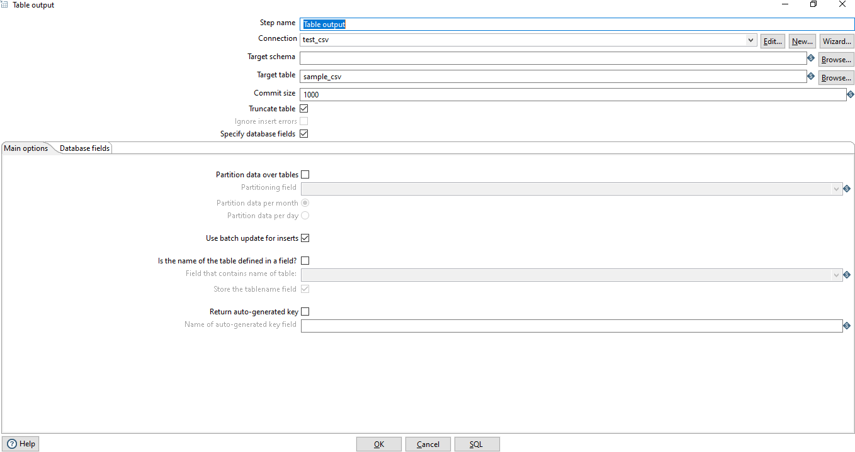

Run transformation

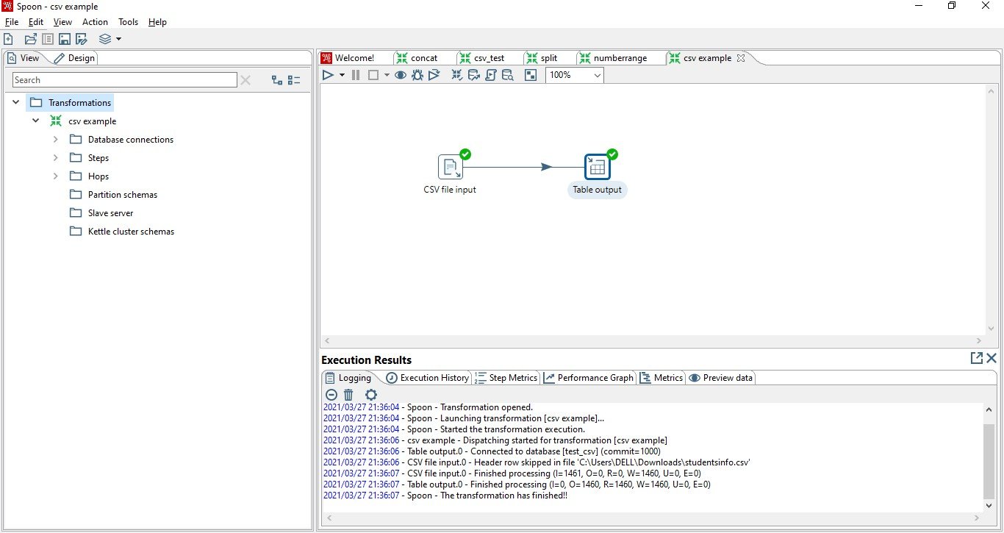

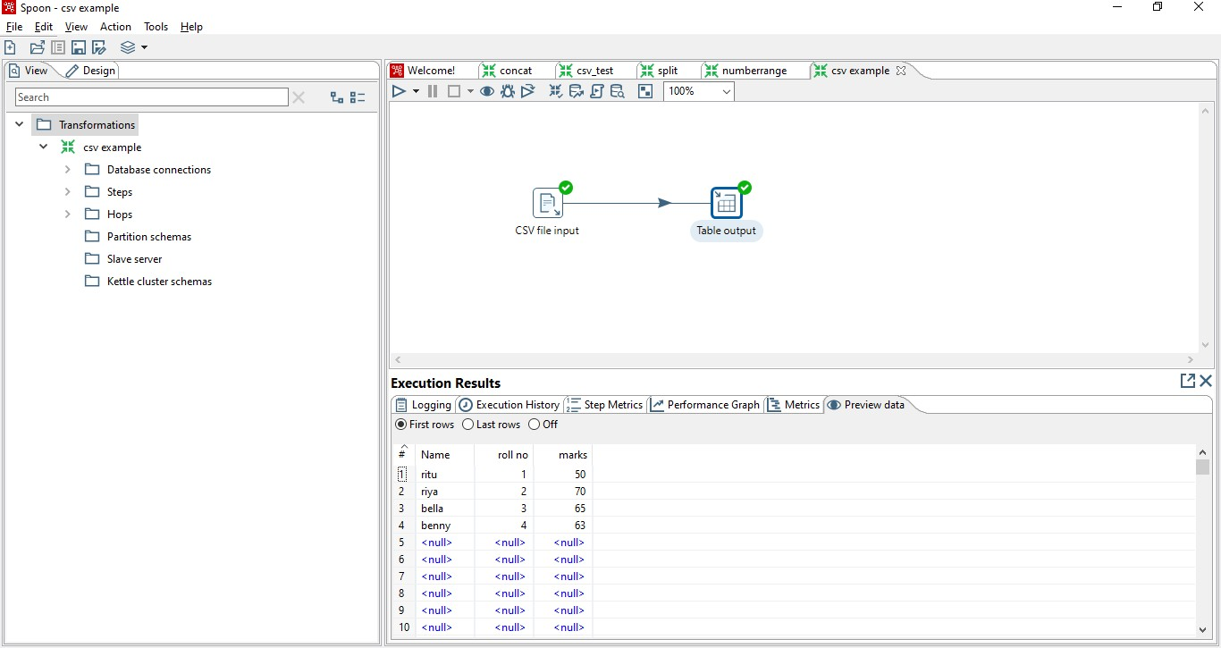

**Merge-join**

##### Create new transformation and Drag & Drop data grid, sort and Merge join.

1. **Double Click on Student data grid table. Enter Columns name.**

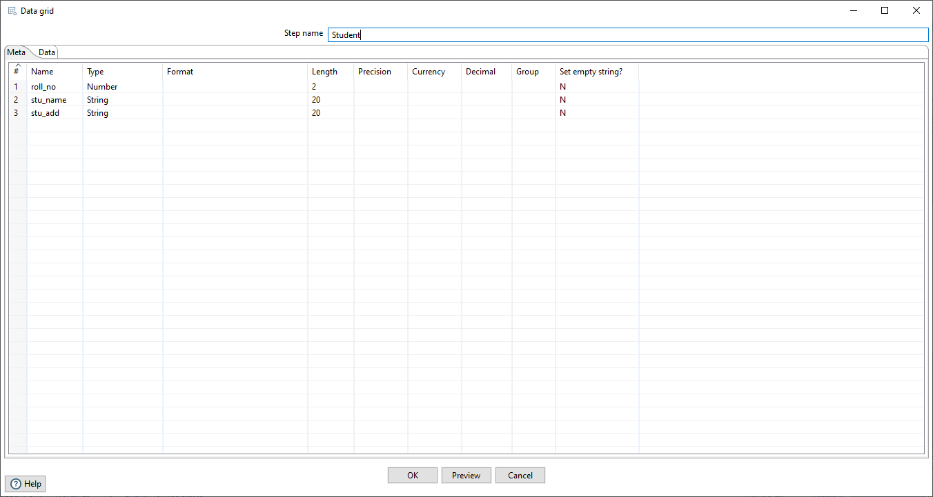

##### Then Click on Data.

1. **Add all the values in columns and click on preview then OK.**

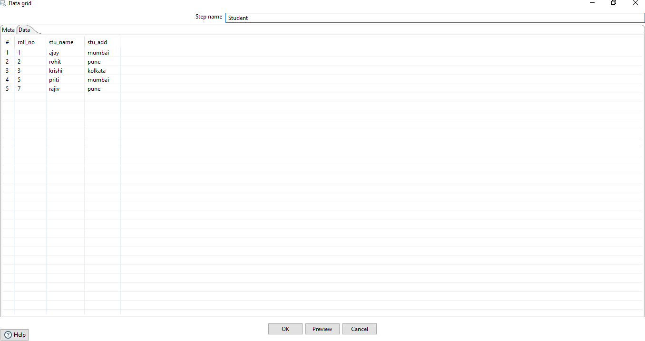

##### Double click on Marks grid table. Enter the columns name.



1. **Add all the values in columns and click on preview then OK.**

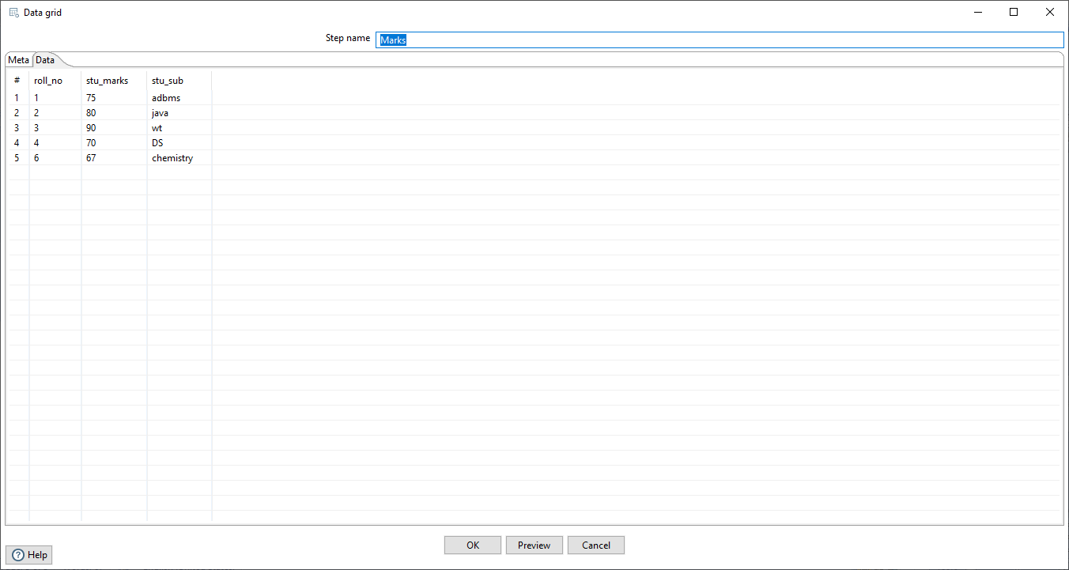

##### Double click on Stu_sort sort rows Add the column on which you want to perform sorting.

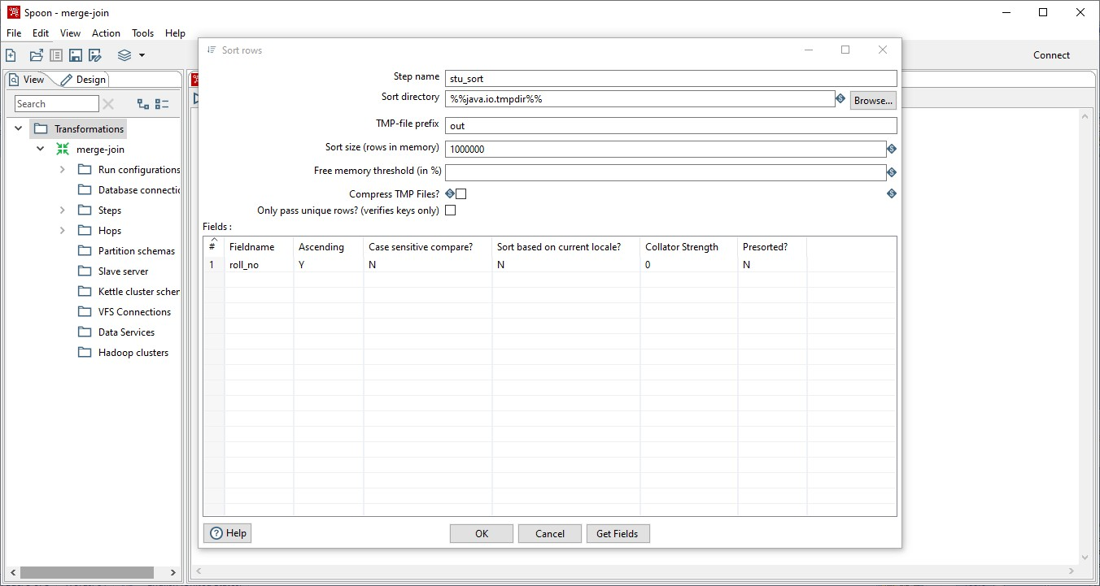

**Click ok.**

##### Double click on marks_sort sort rows Add the column on which you want to perform sorting.

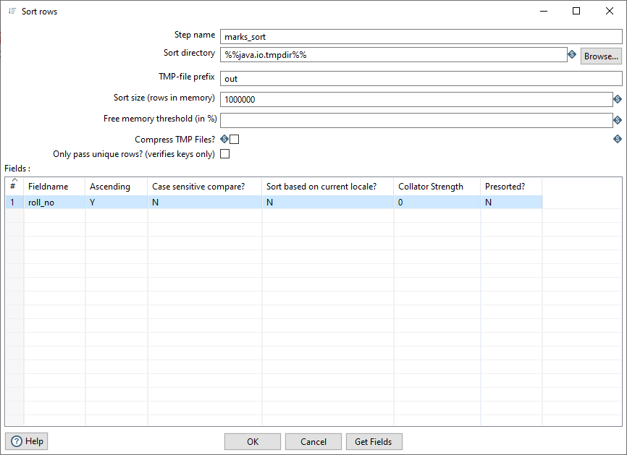

1. **Double Click on merge join and enter the following data.**

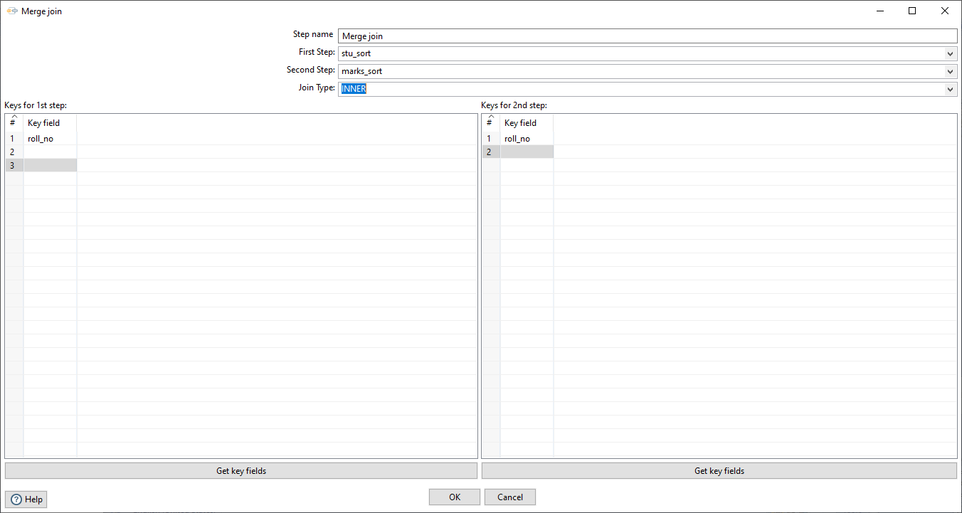

**NOTE: - We can perform inner join, left outer join, right outer join and full outer join by selecting join type.**

1. **Run the transformation.(Inner join)**

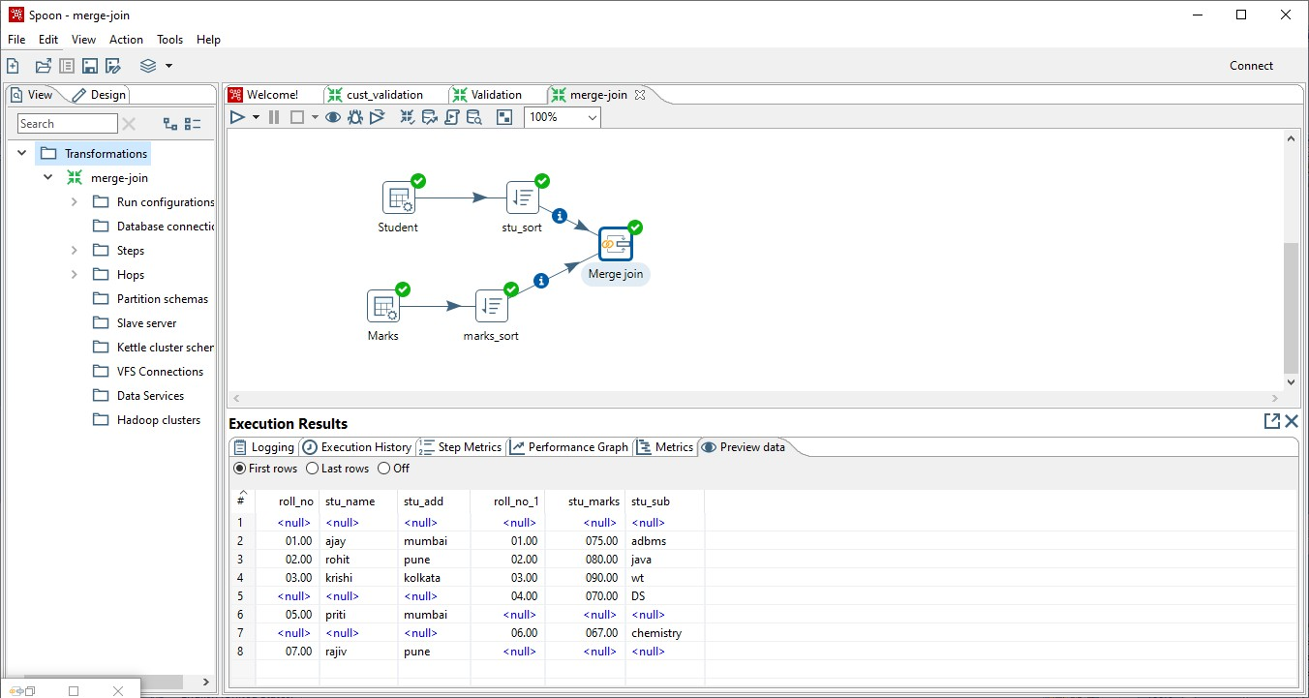

##### Run the transformation.(Left Outer join)

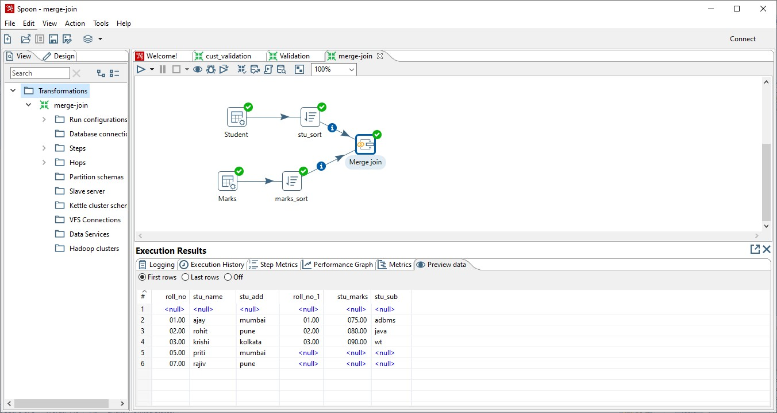

1. Run the transformation (Right Outer Join)

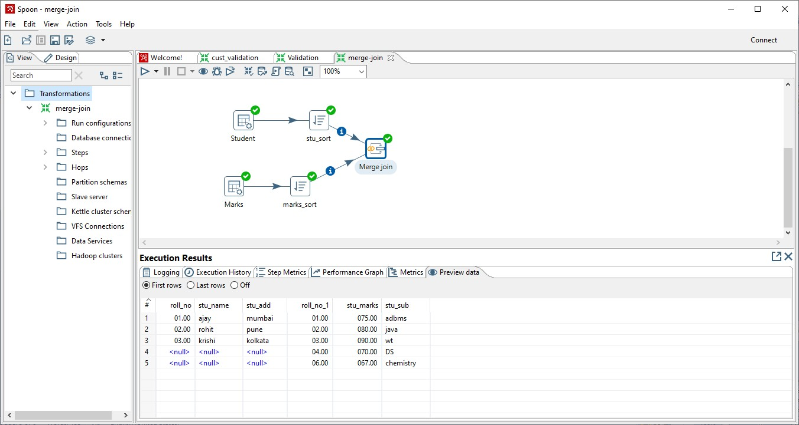

1. Run the transformation (Full Outer Join)

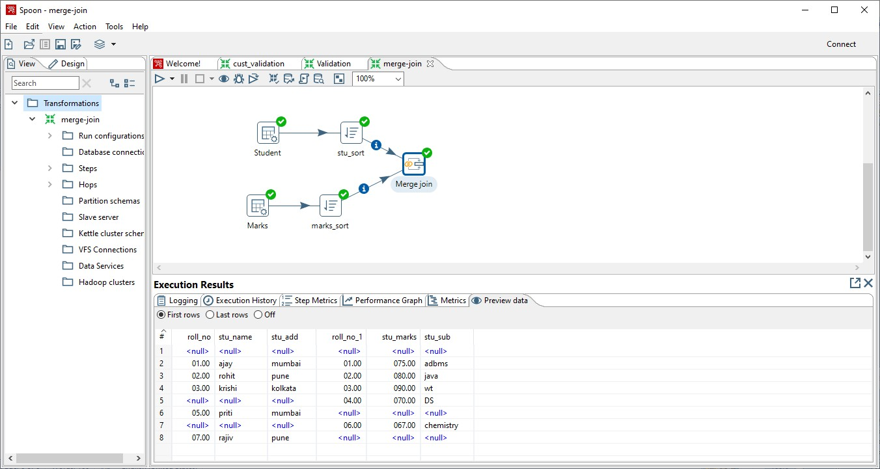

**Validation**

1. Create new transformation and Drag & Drop data grid table, data validation, 2 Dummies and table output table. Connect them with each other.

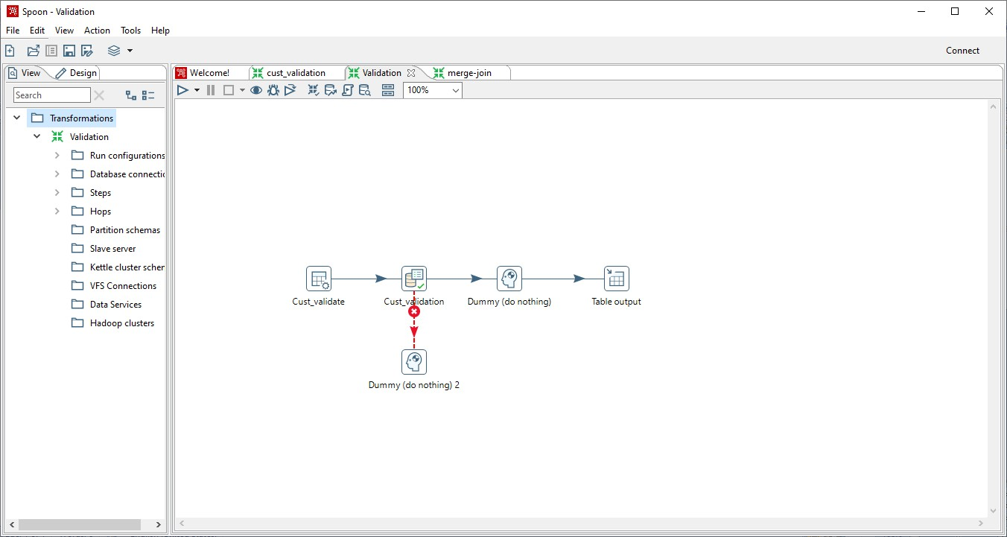

1. Double Click on Cust_validate data grid table.

Enter the entire Columns name.

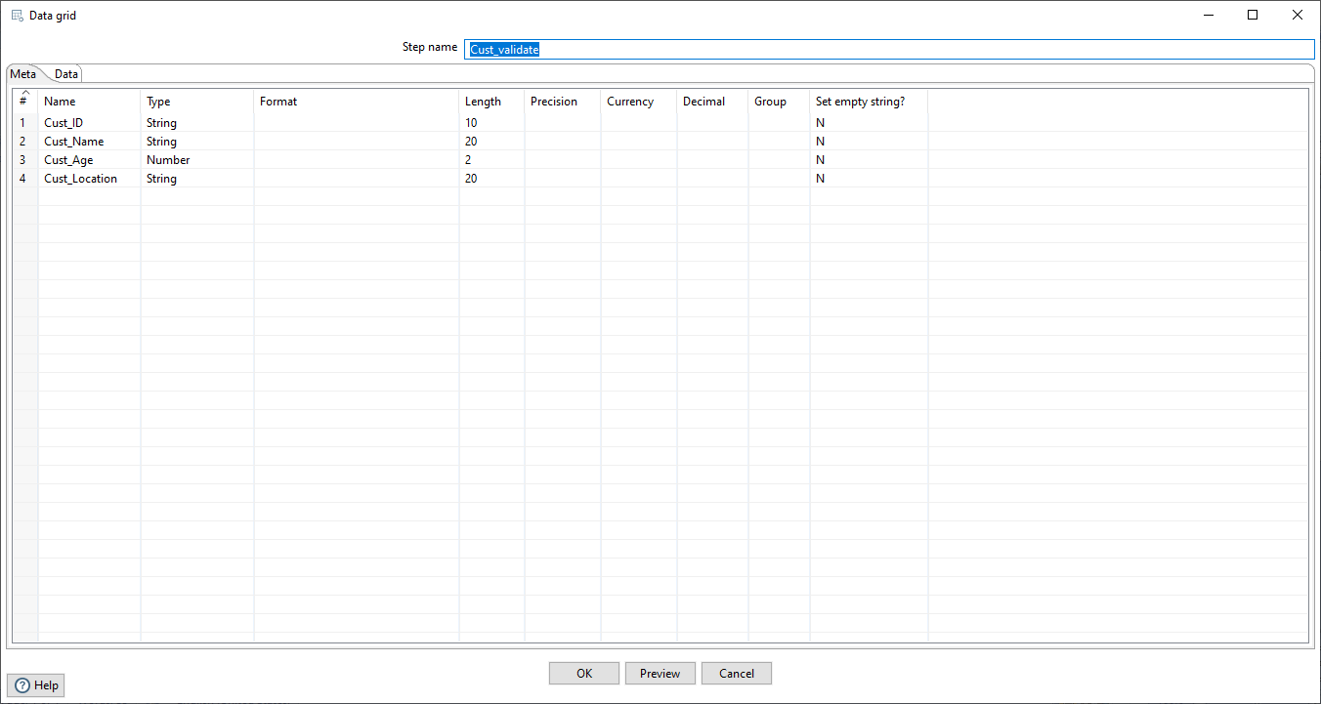

1. Click on data and enter all the values.

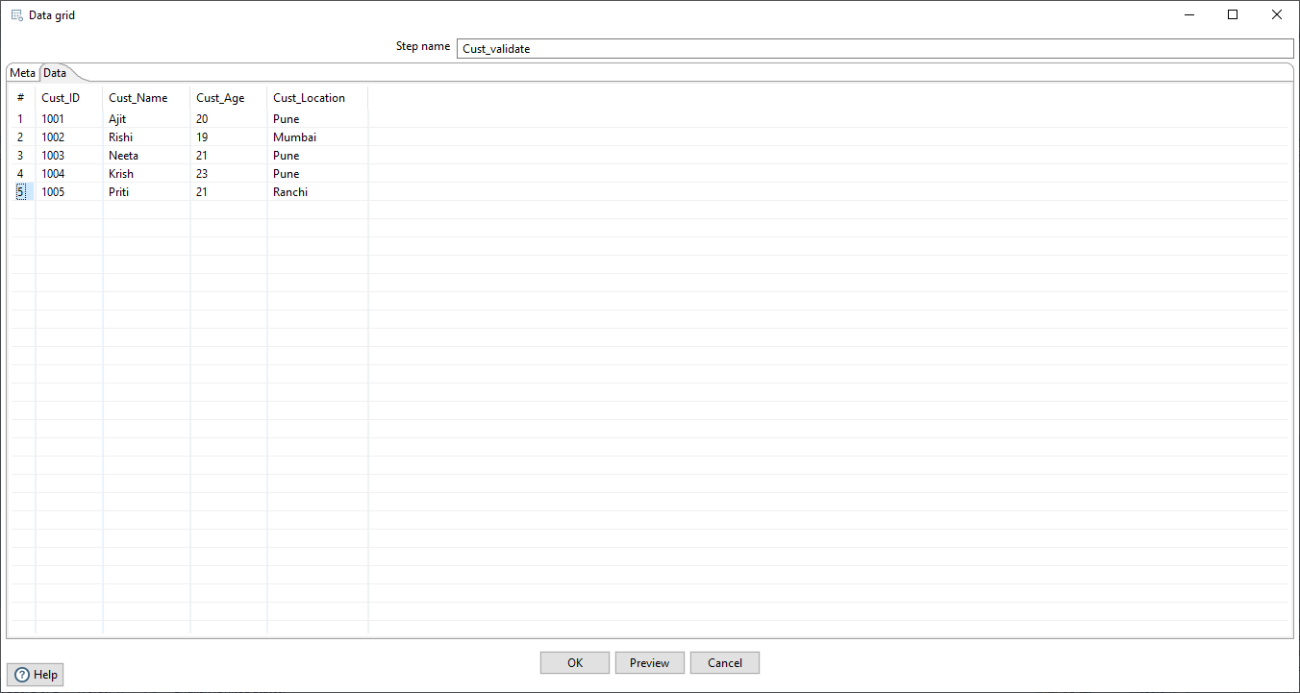

Click ok

1. Double click on Cust_validation and add the felid on which you want to perform validation.

Click on new validation

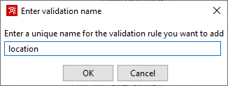

Click ok then you can see the name of validation on left hand side corner double click on that.

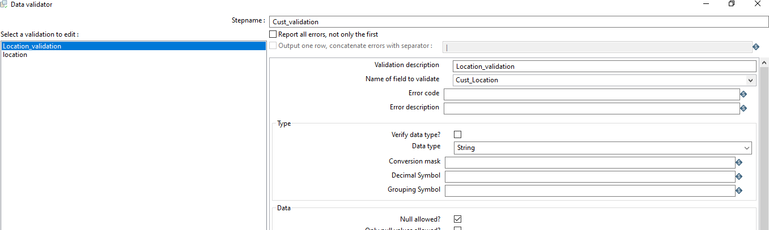

Add on validation value

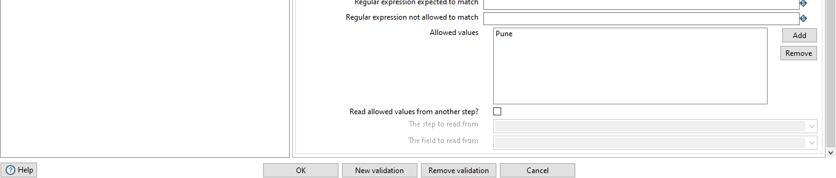

Click on ok.

1. Connect first dummy to main output of step connection.

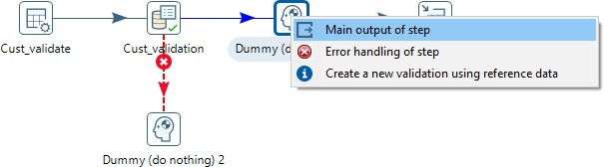

1. Connect second dummy to Error handling of step connection.

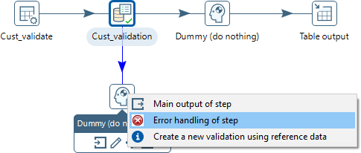

3.Double Click on table_output and enter the following data.

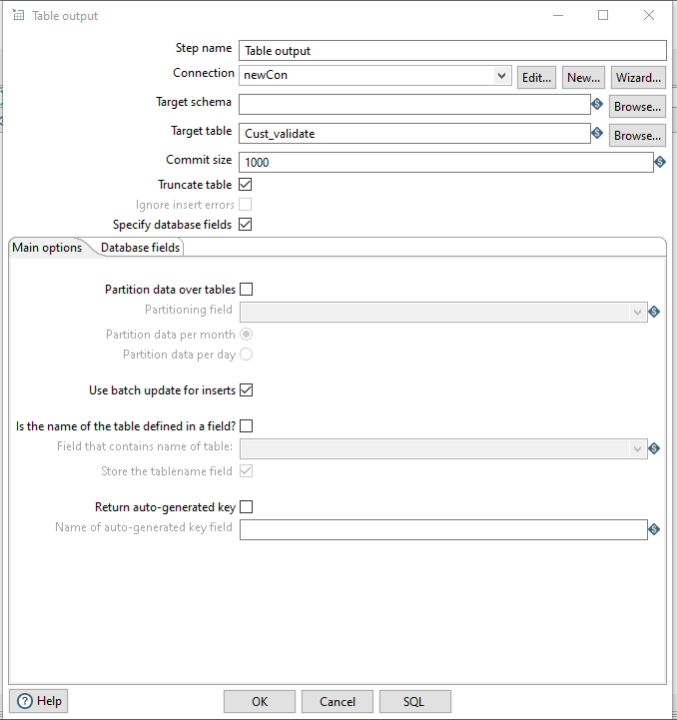

Click on database fields.

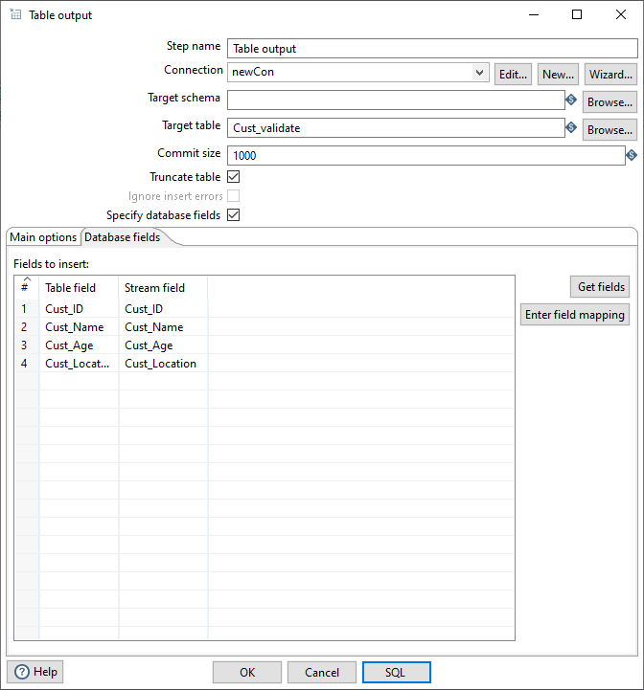

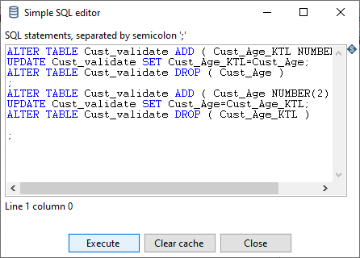

9.Run the transformation.

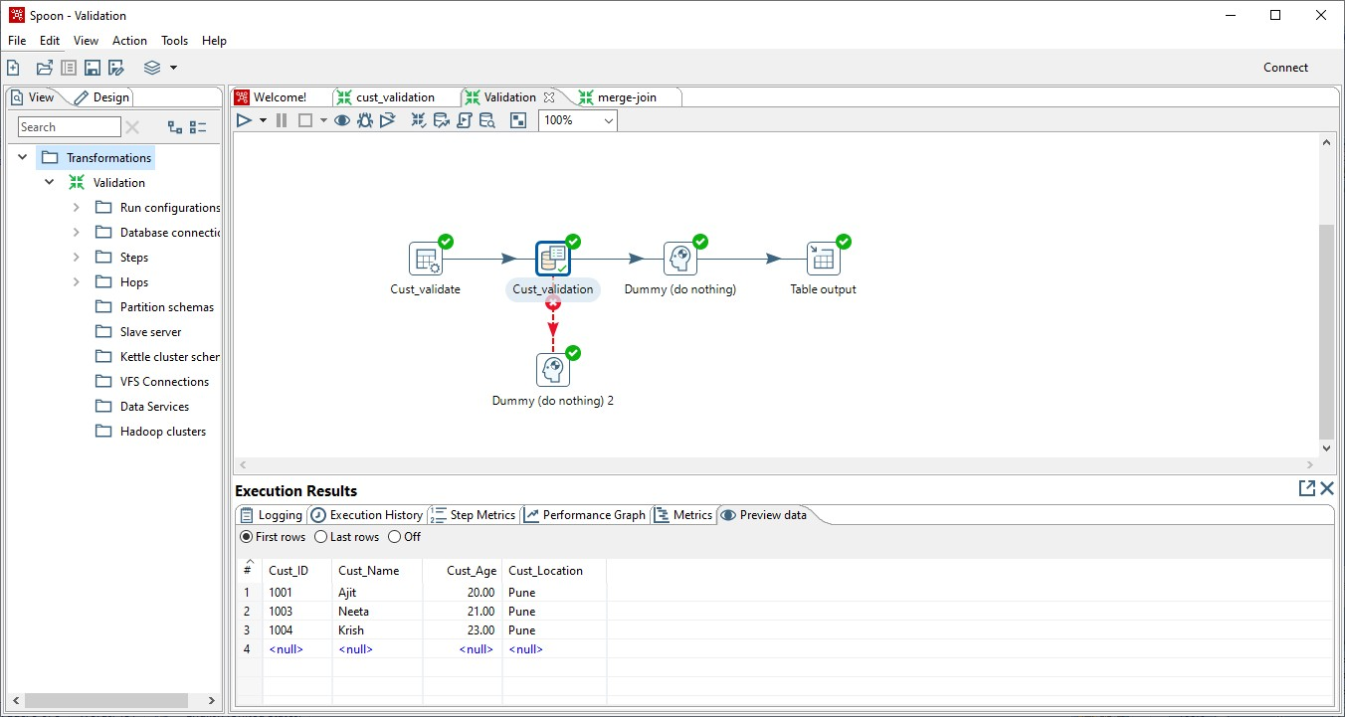

**Practical No: 5**

**Aim: Installation of R Studio**

**\*\*\*\*\*\*\*\*\*\*\*\*\*\*\*\*\*\*\*\*\*\*\*\*\*\*\*\*\*\*\*\*\*\*\*\*\*\*\*\*\*\*\*\*\*\*\*\*\*\*\*\*\*\*\*\*\*\*\*\*\*\*\*\*\***

**Setting working directory**

Setwd(“E:/R_practical”)

1 )Install packages,loading packages



2) Data types,checking types of variable,printing variable and objects



1. Vector,matrix,list,factor,data frame,table





1. cbind-ing,rbind-ing



1. setwd(),getwd()



1. reading data from console,loading data from different data sources(CSV, Excel)



**Practical No : 6**

**Aim : Implementation of Data preprocessing techniques like naming and renaming variables, adding a new variable, dealing with missing data ,dealing with catalogical data, data reduction using sub setting.**

Input:

>mtcars

Output:



Input

>d<head(mtcars,5)

>d<mtcars

>d[1:3]

Output:



1. Naming and renaming variables,adding a new variable

Input:

>install.packages("dplyr")

>library(dplyr)

>require(dplyr)

>rename(d,horse_power=hp) Output:



Input:

>d$new_hp<-d$hp=0.5

>colnames(d)

>View(d)

Output:



2) Dealing with missing data

Input:

>data1<-read.csv("missing_col.csv",sep=",")

>View(data1)

Output:



Input:

>x<-c(1,2,3,NA,4,NA,5)

>x

>is.na(x)

>NA+4

>median(x)

>median(x,na.rm=T)

>xn<-is.na(x)



Output:

3)Dealing with categorical data

Input:

>NA+4

>median(x)

>median(x,na.rm=T)

>xn<-is.na(x)

>!xn

>x[!xn]

>complete.cases(x)

Output:



Input:

>View(data1)

>is.na(data1)

>complete.cases(data1)



4)Data reduction using subsetting

Input:

>install.packages('Hmisc')

>library(Hmisc)

>v<-impute(x,fun=mean)

>v

>v<-impute(x,fun=median)

>v

>v<-impute(data1$SRNO,fun=mean)

>v

>v<-impute(data1$SRNO,fun=median)

>v Output



**Practical No: 7**

**Aim:Implementation and analysis of linear regression through graphical methods.**

Input:

>install.packages("ggplot2") #simple linear regression #predictor variable

x<-c(3,8,9,13,3,6,11,21,1,16)

#response variable

y<-c(30,57,64,72,36,43,59,90,20,83)

>library(ggplot2)

>plot(x,y,col='red',main="scatter plot")



#linear regression model

>model=lm(y~x) >model

>attributes(model)



>coef(model)

>residuals(model)

>summary(model)



>abline(model)

#predicting values manually y=a+bx

>x10<-model$coefficients[[1]]+model$coefficients[[2]]*10 >x10 #using predict()

>a<-data.frame(x=10)

>a

>pred<-predict(model,a)

>pred



>plot(model)



#apriori

>install.packages("arules")

>library(arules)

>install.packages("arulesViz")

>library(arulesViz)

>setwd("C://Users//Shlok//Desktop//ganesh")

>mba_data<-read.csv("data_apriori.csv")

>view(mba_data)



class(mba_data) #method 1

t<-as(mba_data,"transactions")

>class(t)

>inspect(t)



#method 2

>trans<-split(mba_data$Customer_Id,mba_data$Products,"transactions") >trans<- split(mba_data$Products,mba_data$Customer_Id,"transactions") >class(trans)

>inspect(trans)

>head(trans)



>rules<-apriori(trans,parameter=list(support=0.1,confidence=0.4,maxlen=3,minlen=3)) >rules



inspect(rules)



>plot(rules)



**Practical No: 8**

**Aim: Implementation and analysis of classification**

**algorithms like naive Bayesian, k-nearest neighbour,ID3,C4.5**

Implementation of K-Means:

Input:

>install.packages("stats")

>library(stats)

>library(dplyr)

>library(ggplot2) Output:



Input:

>mydata = select(iris, c(1,2,3,4))

>model = kmeans(mydata, 3)

>model

Output:



Input:

>model$cluster

>model$size

>table(model$cluster,iris$Species) Output



Input:

>model$cluster = as.factor(model$cluster)

>ggplot(iris, aes(Petal.Length, Petal.Width, color = model$cluster))+ geom_point() Output:



Implementation of KNN.

Input:

>table(iris$Species)

>str(iris$Species)

>head(iris) output:



Input:

>ir = iris[sample(nrow(iris)),] //shuffle data >head(ir)

//check shuffling Output:



Input:

#Scale data using normalization # create function

>normalize = function(x) {

> return( (x-min(x))/(max(x)-min(x)))

>}

# normalize iris data

>iris_n = as.data.frame(lapply(ir[,c(1,2,3,4)], normalize))

>str(iris_n)

output:



Input: >head(iris_n) Output:



Input:

# Creating the trianig and test set

>iris_train = iris_n[1:129,]

>iris_test = iris_n[130:150,]

>iris_train_target = iris[1:129,5]

>iris_test_target = iris[130:150, 5]

>df = as.data.frame(iris_train_target)

>library(class)

#model = knn(iris_train, iris_test, cl = df, k=13) #check the dimension of the dataset

>dim(iris_train)

>dim(iris_test)

>dim(df)

>model = knn(iris_train, iris_test, cl = iris_train_target, k=13)

>table(iris_test_target, model)

Output:



Naïve Based classification method

Input:

>install.packages("e1071");

#Contains naive bayes classifier

>library(e1071);

Input:

>



Input:

>ir = iris

>View(ir)

Output:



Input:

>train = ir[1:100,] #Training set

>test = ir[101:150,] # Test set

>model = naiveBayes(Species ~., data = train)

>pred = predict(model, test)

>pred

Output:



Input:

>table(pred)

>table(test$Species)

>table(train$Species)

Output:



Input:

# Suffle iris file

>ir1 = ir[sample(nrow(ir)),]

>train = ir1[1:100,] #Training set

>test = ir1[101:150,] # Test set

>model = naiveBayes(Species ~., data = train)

>pred = predict(model, test)

>pred Output:



Input:

>table(pred)

>table(test$Species)

>table(train$Species)

Output:



**Practical NO:9**

**Aim : Implementation and analysis of apriori algorithm using market analysis.**

Input:

>data("Groceries")

>attributes(Groceries)

>inspect(head(Groceries,3))

Output:



>View(Groceries)



model<-apriori(data=Groceries,parameter=list(support=0.001,confidence=0.15))



>inspect(head(model,3))



**Practical No: 10**

**Aim:- Implementation of K-Means**.

Input:

>install.packages("stats")

>library(stats)

>library(dplyr)

>library(ggplot2)

Output:



Input:

>mydata = select(iris, c(1,2,3,4))

>model = kmeans(mydata, 3)

>model

Output:



Input:

>model$cluster

>model$size

>table(model$cluster,iris$Species)

Output:



Input:

>model$cluster = as.factor(model$cluster)

>ggplot(iris, aes(Petal.Length, Petal.Width, color = model$cluster))+ geom_point()

Output:

